Dictionary of Archives Terminology
  - Style Guide and Production Manual
27 May 2016

Table of Contents

1. Introduction 6
1.1. Purpose of This Manual 6
1.2. History of the Dictionary of Archives Terminology 6
1.3. SAA Dictionary Working Group 6
2. Style Guide 7
2.1. Introduction 7
2.1.1. Explanations of Technical Terms in Lexicography 7
2.2. Abbreviations 7
2.2.1. As Main Entries 7
2.2.2. As Used in Dictionary Entries 7
2.3. Audience 8
2.4. Biographical Entries 8
2.4.1. Rules for Inclusion 8
2.4.2. Writing 9
2.5. Capitalization 9
2.5.1. Use 9
2.5.2. In Main Entries 9
2.6. Citations 10
2.6.1. Collecting Citations 10
2.6.2. Order of Citations 10
2.6.3. Choosing Citations 10
2.7. Corpus 10
2.7.1. Description 10
2.7.2. How to Search 10
2.7.3. How to Use in Dictionary 10
2.8. Cross-references 10
2.8.1. When Required 11
2.8.2. How to Mark 11
2.8.3. As Main Entries 11
2.8.4. Cross-references to Specific Senses 11
2.9. Definition 11
2.9.1. General 11
2.9.2. Examples 12
2.10. Dictionary Entry Structure 12
2.11. Etymology 13
2.12. Headwords 13
2.12.1. Formatting Headwords 13
2.13. Illustrations 13
2.13.1. When to Include Illustrations 13
2.13.2. Specifications for Illustrations 14
2.13.3. Sourcing Illustrations 14
2.13.4. Formatting of Credits 14
2.14. Inflected Forms 15
2.14.1. When Included 15
2.14.2. Which Forms to Include 15
2.14.3. When also Entered as Cross-reference Entries 15
2.15. Labels 15
2.15.1. General 15
2.15.2. Regional Labels 15
2.16. Lexicon 16
2.16.1. General Principle 16
2.16.2. Inclusion of Terms 16
2.17. Marked Forms 17
2.18. Notes 17
2.18.1. When to Include Notes 17
2.18.2. When Not to Include Notes 18
2.18.3. Writing Notes 18
2.18.4. Identifying a Particular Sense of a Word in a Note 18
2.18.5. Usage Notes 19
2.19. Order of Headwords 19
2.19.1. Alphabetization 19
2.19.2. Exceptions 19
2.20. Order of Senses 19
2.20.1. Where Parts of Speech are the Same 19
2.20.2. Where Parts of Speech are Different 19
2.21. Parentheses 19
2.22. Parts of Speech 19
2.23. Pronunciation 19
2.23.1. General Principles 20
2.23.2. Formatting Pronunciations 20
2.23.3. Simplified Pronunciation Key 21
2.24. Punctuation 22
2.25. Run-on Entries 22
2.26. Sample Entries 23
2.27. Sets 23
2.27.1. Recognized Sets in DAT 23
2.27.2. Defining Terms within Sets 24
2.28. Spelling 24
2.28.1. General 24
2.28.2. Alternative Spellings 24
2.28.3. Compound Common Nouns 25
2.28.4. Compound Proper Nouns 25
2.28.5. Compound Proper Adjectives 25
2.28.6. Sources (Bibliographic Entries) 25
2.28.7. Subject Tags 27
2.28.8. Variants 29
3. Production Manual 30
3.1. Reading Program 30
3.2. Dictionary Software 30
3.3. Drafting Entries 30
3.4. Editing Entries 30
3.5. Word of the Week 30
3.6. Adding Sources 30
3.7. Versioning 33
4. DPS 4 Documentation: Getting Started with the Online Editor 35
4.1. Logging in 35
4.1.1. Procedure 35
4.1.2. Prerequisites 35
4.2. Working with Documents 35
4.2.1. Finding and Downloading Documents 35
4.2.2. Explanation 38
4.3. Viewing Documents 41
4.3.1. To View the Document with Different Styling 41
4.3.2. To view Selected XML Tags in the Current Style 42
4.3.3. To edit a Document 43
4.3.4. Working with Document Versions 43
4.3.5. Explanation 46
4.4. Managing Your Personal Workspace 46
4.4.1. In the Dashboard 46
4.4.2. In the Workspace 47
4.4.3. Explanation 48
4.5. Editing Documents 52
4.5.1. In the Dashboard 52
4.5.2. In the Edit Document Tab 53
4.5.3. Explanation 67
4.6. Working with Publications 70
4.6.1. Viewing Publications 70
4.6.2. The Publication View 72
4.6.3. Bulk Operations 72
4.7. Working with Media 72
4.7.1. Searching Media Records 72
4.8. Viewing Media Records 77
4.8.2. Working with Media Record Versions 80
4.8.3. Explanation 83
4.8.4. Creating Media Records 84
4.8.5. Explanation 85
4.8.6. Inserting Media into Documents 85
5. Appendices 90
5.1. DAT Staff 90
5.2. Lexicographer’s Initials for Subject Tagging 90

Introduction

Purpose of This Manual

This manual is divided into four sections, each with a specific purpose:

- The purpose of the opening Style Guide is to document the rules used by the Dictionary Working Group to format and create entries in Dictionary of Archives Terminology.

- For details on the more bureaucratic processes of DAT, see the Production Manual, also included in this document. The Production Manual provides information on the DAT reading program, the assignment entries to a lexicographer, the editing of dictionary entries, the maintenance of editions or iterations of DAT, and the differing formatting standards and process for the DAT Word of the Week.

- For details on how to use IDM’s Dictionary Production System, see DPS 4 Documentation.

- For lists of those who have worked on DAT, see the Appendices.

History of the Dictionary of Archives Terminology

SAA Dictionary Working Group

Style Guide

Introduction

Explanations of Technical Terms in Lexicography

antedating

citation

corpus

etymology

headword

label

lemma (lemmata, pl.)

lexicon

marked form

sense

Abbreviations

As Main Entries

Use abbreviations in main entries only in cases where

- the abbreviations refer to the full use of the term (for instance, “SAA” referring to the entry “Society of American Archivists” or “ALS” for “autograph letter signed”)

- where the abbreviated form is the most common form of the term (“ISO 2108”)

As Used in Dictionary Entries

The following abbreviations are those accepted for use in DAT:

Parts of Speech

abbr. abbreviation

adj. adjective

adv. adverb

n. noun

v. verb
(No distinction is made in DAT to distinguish between transitive and intransitive verbs)

Noun Clarification

pl. plural

¶ pilcrow or paragraph mark
(Use to show the beginning of a new paragraph is a quoted use of a headword in a citation)

Other

This abbreviation is used only in entries that include notations about alternative spellings.

sp. spelling

Thesaural Terms

Abbreviation | Full Name | Meaning
BT | Broader term | A heading for more general concept.
DF | Distinguish from | A heading that is similar, and that is identical but often confused.
NT | Narrower term | A heading for a more specific concept.
RT | Related term | A heading that is closely associated.
Syn | Synonym | A heading with very nearly the same meaning.
See | See other entry | A heading with fuller discussion of the entry.

Audience

Although the primary audience for DAT is archivists and allied colleagues, write entries at a tenth-grade level so that DAT can be used as an outreach tool to explain archives to laypeople.

Although DAT archivists of the United States are the primary audience for DAT, we recognize that DAT will be used across the English-speaking world and beyond, so write entries specifically for an American audience while understanding the readership of DAT will be worldwide.

Biographical Entries

Rules for Inclusion

Requirement for Inclusion

Biographical entries will be included only for the deceased.

Professional Contributions

Biographical entries will be included only for individuals who have made significant national or international contributions to the archives profession.

Writing

Core of Data for Biographical Entries

When appropriate, base entries on biographies in the card set “SAA@75” published by the Society of American archivists in 2011.

Length

Biographies will be brief and not exceed one sentence in length.

Content

Include certain information in all biographical entries within DAT:

Lifetime
Include at the end of the entry the four-numeral years of birth and death of the individual within parentheses and separated by an en-dash rather than a hyphen. For example: (1895–1955).

Names
Include any maiden names or alternate names of individuals. For instance, for a woman who married and changed her surname, include within commas the word née (always italicized) followed by the woman’s middle name.

Achievements
Focus the biography on the essentials of the individual’s career in archivy, including major theoretical concepts championed, major books written, and institutions most associated with.

Capitalization

Use

In Main Entries

Citations

A citation, as the term is used in this style guide, is quoted text collected by a DAT lexicographer because it uses a relevant term in context. The Dictionary of Archives Terminology is a citations-based dictionary, so citations are essential to the job of creating and maintaining this dictionary. Since the context of a word clarifies its meaning, DAT lexicographers collect citations in order to more carefully identify the senses of terms as used in the archives profession.

Collecting Citations

In general, use three considerations determine whether or not to include a citation in DAT:

- The citation provides enough context to make clear the meaning of the word.

- The date of the citation helps demonstrate the chronological range of the use of the word. Most commonly, this means always collect and record the earliest known use of a certain sense of a lemma (such a citation is known as an antedating), the latest known use of a sense for less common terms (such as citation is known as a postdating), and at least a few citations between these extremes to demonstrate continuing use.

- The citation is relatively brief (although longer citations are acceptable when necessary).

Order of Citations

Citations will be presented in chronological order from earliest to latest citation. In the case of a lemma with multiple senses, citations for each sense will be presented in chronological order by sense. All citations relevant to a particular sense of a lemma will appear in DAT under the relevant sense to ensure the association of citations with senses.

Choosing Citations

The general editor of DAT makes the final decision on which citations will remain within DAT and which will be displayed in the online instance of DAT.

Corpus

Description

How to Search

How to Use in Dictionary

Cross-references

When Required

How to Mark

As Main Entries

Cross-references to Specific Senses

Definition

General

Structure of Definitions

Begin every definition with a lower-case letter.

Do not add a period or other punctuation to the end of a definition.

If a headword includes multiple senses, sequentially number the definitions, starting with 1 assigned to the most common sense.

Writing Definitions

Write definitions in such a way that each definition can replace the headword as used in a sentence.

Write definitions as concisely as possible, but do not avoid length in a definition of that is needed to create a complete definition of the word.

Ensure that every definition addresses all canonical attributes of the meaning of the word being defined. For instance, if defining the term accession log, the definition must include the fact that such a log records accessions and that it records accessions in chronological order of receipt. Without both canonical attributes, this term is not properly defined.

Defining Lemmata Also in General Non-Technical Use

In cases where a technical term in archives also has generic use in English, define the word not in its narrow generic sense but in its more precise sub-sense in archives. For instance, the term value in archivy is defined in DAT as “the usefulness, significance, or worth that determines a record’s retention,” the beginning of which is a generic definition but the whole of which discusses the worth of records and how that worth informs retention decisions in archives and records management.

Punctuation in Definitions

In general, use punctuation within definitions in conformance with the most recent edition of The Chicago Manual of Style. The following are basic guidelines regarding the use of punctuation:

- Use punctuation sparingly and only when necessary.

- Do not use parentheses, dashes, or colons in any definition. If such marks seem necessary within the definition as written, simplify the definition.

- Periods: Do not end a definition with a period. Instead, end without any punctuation.

- Semi-colons: Use semi-colons in definitions only when separating two differently written but essentially synonymous definitions for one sense of a lemma. Even such use should be rare.

Examples

Dictionary Entry Structure

Arrange dictionary entries according to the structure below, but for details refer to discussions in this style guide of specific parts of the dictionary:

headword

Relationships

Notes

Sentences about the use and history of the headword.

part-of-speech, pos-abbr. ~ [PRO-nuhn-see-AY-shən] (also sp. alternative-spelling) (irregular plural form, pl.; abbreviated form, abbr.)

1. Subject Tag · Subject Tag · definition of the most common sense of the term

Citations

(Source Abbreviation: page-number) Text of the chronologically earliest citation using ellipses…if any text was deleted and [brackets for any clarifying added text, usually an explanation of a referent that is not clear within the citation].

(Source Abbreviation: page-number, fn. number-of-footnote-on-page) Text of the chronologically second earliest citation.

(Source Abbreviation: page-number) Text of the most recent citation.

2. Subject Tag · definition

Citations

(Source Abbreviation: page-number) Text of the chronologically earliest citation.

(Source Abbreviation: page-number) Text of the chronologically most recent citation.

3. Subject Tag · definition

Citations

(Source Abbreviation: page-number) Text of the chronologically earliest citation.

(Source Abbreviation: page-number) Text of the chronologically most recent citation.

Illustration
(Citation for Illustration, including year)

Etymology

Since DAT is not a dictionary on historical principles, it does not include the derivations of words. However, pertinent and interesting explanations of the coinage or etymologies may be included in the Notes for an entry. See, for example, this note from the entry for archivy.

The word “archivy” is probably unique in that we know exactly when it was coined: on 19 June 1937 during the first meeting of the Society of American Archivists. An article in the Washington Star published the next day outlines the story: “‘This meeting,’ one of them said, ‘is the beginning of a new era in archivy.’ ¶Immediately, all who heard the word pounced on it—and took it into the fold. In the excitement, no one could recall the name of the author.” The term “archivy” is not used commonly in the field, but (as even the article from 1937 noted) it allows the profession a distinct term to use instead of the polysemous “archives,” which we use for a set of records, a building, an organization, or the entire field itself.”

Headwords

Formatting Headwords

Illustrations

Illustrations are employed in DAT to help users better recognize physical objects and artifacts found in the world of archives.

When to Include Illustrations

DAT includes illustrations in those limited instances where a simple illustration can define a term, provide more detail about the term, and help users identify the term with the physical object it represents.

In general, illustrations will be included in the following cases:

- To provide visual information about different hardcopy and digital media

- To allow for the visual recognition of different record formats and record types, and to provide additional information about the general content of record types

- To allow for the visual recognition of manual and digital tools commonly used in archival practice

Specifications for Illustrations

Use the following guidelines to ensure the capture or acquisition and the use of high-quality illustrations within DAT:

- Any illustration used in DAT must be in perfect focus and otherwise clearly visible

- Any illustration must be a good example of the general appearance of the object being defined in the related dictionary entry. Just as any definition must mention the canonical attributes of any term being defined, any illustration must document the canonical physical features of that object the term refers to.

- Since DAT is an online resource, illustrations may be bitonal, grayscale, or color.

- Illustrations in DAT must be used in such a way as to ensure broad coverage of the archival world in terms of types of records, types of tools, types of archives, and regions of the United States of America.

Sourcing Illustrations

All illustrations must include information on the source of the illustrations, including

- the term for the type of record or tool

- details on the illustrated record or tool

- the year of creation of any record used as an illustration

- credits to the archives that allowed use of the image (if applicable)

- the name of the photographer who took the photograph (if applicable)

Formatting of Credits

All illustrations must include credits for the illustration that follow this format:

Parchment, A Court Writ Signed by James De Lancey, Chief Justice of New York, 1756
(Division of Old Records, New York County Clerk, photography by Geof Huth)

Credits for an illustration must appear centered and just beneath the illustration itself.

Inflected Forms

When Included

Which Forms to Include

When also Entered as Cross-reference Entries

Labels

General

Labels, more commonly referred to as “tags” in archivy, are used in a variety of ways in DAT: to show regional use of the term, to assign terms to subject categories, and to demonstrate one term’s relationship to other terms.

Assignment of Labels

Assign tags to the headword in cases where the headword has only one sense or cases where all senses of the terms are accurately covered by the same tag. Assign tags to individual senses in cases where the tag applies only to certain senses of the headword.

Number of Labels

Assign any number of appropriate tags to any headword or individual sense of a headword. In such cases, separate tags from each other by a comma.

Regional Labels

Use of

Use regional tags only in instances when a term is used primarily or exclusively in part or parts of the English-speaking world.

Do not assign regional tags to biographical entries or entries for organizations.

Definition of Regional Labels

The following are the only regional labels used within DAT:

American
Use in instances where a term is used primarily or exclusively in the United States of America.

Australian
Use in instances where a term is used primarily or exclusively in the Commonwealth of Australia.

British
Use in instances where a term is used primarily or exclusively in the United Kingdom of Great Britain and Northern Ireland.

Commonwealth
Use in instances where a term is used primarily or exclusively in the 53 member states of the Commonwealth of Nations.

Canadian
Use in instances where a term is used primarily or exclusively in Canada.

North American
Use in instances where a term is used primarily or exclusively in Canada and the United States of America.

Modifiers

In cases where a regional tag is used primarily but not exclusively in a certain part of the English-speaking world, modify the tag with the term “Chiefly.”

Example: Chiefly Canadian.

Associate “Chiefly” only with individual regional tags, even if the modified term applies to more than one geographical region.

Example: Say “Chiefly British, Chiefly Canadian,” not “Chiefly British and Canadian

Lexicon

General Principle

The dictionary will include and define terms that will help those working in archives, records management, special collections, and curation to speak clearly to one another. The dictionary will also define terms needed to understand the activities, functions, techniques, and theory of digital curation, manuscripts, records management, and special collections as related to archives.

Inclusion of Terms

Terms needed in order for archivists to understand or perform archives-specific functions. These are terms not usually found in other reference sources or the sources do not refer to archives applications or theory.

Either the definition will provide the archival sense of the term or the notes will provide the archival utility.

We would prefer that standards refer to the DAT for the authoritative definition. However, recognizing that there may be terms that are crucial to understanding the standard but are not included in the DAT (for example, a term that specifically does not fit our inclusion policy – which is why we started working on that, or a term that is so new we need the standard to first define it so we have it being presented in the archival literature so we can include it), standards must be able to include glossaries. I do not remember if we talked about or decided that the standard should reprint our definition in a glossary or have a stock statement about where to find definitions. Does anyone remember that part?

As we beginning a process of updates for the DAT after the initial release, we could add a review of new standards terminology as a standard part of the process. However, we are not there yet.

Questions about what should be included...

- Electronic file formats: which ones?
- record types: which ones?
- Specific computer programs or tools: which one?

(a potential answer to this question...when possible, use generic terms (i.e. “web harvesting services” instead of “Archive-It”) and include specific examples of products in notes. Separate entries may be developed for products that have been developed for the archival community.

Notes

Notes in DAT are brief explanations of the meaning and use of lemma. Notes are not used frequently, and every entry does not need to include a note.

When to Include Notes

Add notes only when the note

  - Provides information of an encyclopedic nature that archivists would need to better understand the terms and do their work (not on the words or definitions precisely, but on things like how certain technologies functioned)

  - Provides interesting historical information on the coinage of the term or the ways in which the senses of the term have changed over time

  - Provides additional information to differentiate between senses of a term when such information would make the definitions in the entry too long or complicated

When Not to Include Notes

Do not include notes in cases where

  - The uses and senses of the term are stable and easy to understand

  - The differences between senses have been completely clarified within the definitions themselves

Writing Notes

A few rules guide the writing of notes

- Write notes that are as brief as possible, but occasionally notes will be longer because they have more to address.

- If you provide a note to explain one sense of a polysemous word, you do not have to discuss every sense of the word. Address only the issues that need to be addressed.

- When writing a note about one sense of a polysemous word, always identify the pertinent sense of the word.

- Italicize any word you refer to as a word. For instance, say, “Sometimes, archivists use archives to mean the building or storage area for the records rather than the records themselves.” Do not place such uses of words within single or double quotations marks.

- When using the headword to refer to the concept or object the headword refers to, do not italicize the word. For example, say, “Cartes-de-visite remained popular through the early 1880s, when they were superseded by the larger cabinet card.”

Identifying a Particular Sense of a Word in a Note

If a note refers to a specific sense of the term, refer to the sense by adding after the lemma a superscript numeral that coincides with the numbered sense of the word, as in this example:

Folders¹ usually have tabs where a title can be written. Tabs commonly run a fifth, a third, a half, or the full length of the folder, and may be staggered. Five Xerox employees, working on an early graphical user interface (for the Star Information System) intentionally chose to employ folder² in a computing sense to help users better understand how to navigate within the system. They explained this in the article “Designing the Star User Interface” from the April 1982 issue of Byte: “We decided to create electronic counterparts to the physical objects in an office: paper, folders, file cabinets, mail boxes, and so on—an electronic metaphor for the office.” Timetables and brochures are common examples of folders³ in the third sense.

In this case, the superscript numeral 1 identifies the most common sense of the word folder, as a sturdy but thin piece of folded cardboard used to store papers; the numeral 2 identifies the common metaphoric use of folder as a storage location for digital files; and the numeral 3 identifies the least common sense of the word.

Usage Notes

Order of Headwords

Alphabetization

Exceptions

Order of Senses

Where Parts of Speech are the Same

In such cases, the most common sense of the word, as used in the archives profession, must come first, followed by the less common sense. Determine the commonness of the sense based on the number of citations found and recorded.

Where Parts of Speech are Different

In such cases, present the senses in this order:

- Noun
- Verb
- Adjective
- Adverb
- Derivatives (which include gerunds of nouns within the first)

Parentheses

Parts of Speech

Pronunciation

Although DAT is a sophisticated lexicographic resource, it is not designed to be a general purpose dictionary, so it includes pronunciation guides to headwords only in special circumstances.

General Principles

Include pronunciation guides to words only in the following instances:

Pronunciation differs within the profession (for example, the pronunciation of “archivist,” which is both “AR-kə-vəst” and “ar-KIGH-vist”)

Pronunciation differs from the most common pronunciation in the general populace (such as “provenance,” which is pronounced “PRAH-və-nənss” by most but “PROH-və-NAHNSS” by North American archivists)

Pronunciation of the word is ambiguous given its spelling (one case of this is “zine,” which is shortening of “magazine,” making “ZEEN” the pronunciation, but which is sometimes pronounced as “ZIGHN” by those who do not know the etymology of the word)

Pronunciation of foreign words used in English where no common pronunciation exists in English (such as the term “Bertillon card,” the first element of which is pronounced “burr-TIL-yən”)

Pronunciation of the word may be unknown to many native speakers of English (an example of this is “muniment,” which is properly pronounced “MYOO-nə-mənt,” but which people new to the word sometimes pronounce “MUH-nə-mənt”)

Pronunciation of a headword that is an abbreviation does not follow the expected pronunciation of the word as an acronym or an initialism (example: the file extension and digital file format “WAV,” which is pronounced “WAYV,” rather than “WAAV”)

Formatting Pronunciations

Use the following rules to format pronunciation guides for individual headwords:

- Place any pronunciation guide directly after the tilde (~) that follows the part of speech indicator for the headword.

- Enclose the pronunciation guide between square brackets: [ ].

- Determine the respelling of the pronunciation based on the Simplified Pronunciation Key.

- Insert a hyphen between every sequential pair of syllables in a word.

- Display every letter of any accented syllable in CAPITAL LETTERS, and display every letter of any unaccented syllable in lower case letters.

- If there exist two commonly accepted pronunciations of a headword within the US archives profession, separate each with a comma and put the more common pronunciation first.

Simplified Pronunciation Key

This pronunciation table is based on the “Pronunciation respelling key” used in the English language version of Wikipedia. However, many changes have been made to the system, including the narrowing of the range of English accents represented, the elimination or replacement of phonemic replacements symbols and symbol sets, the simplification of International Phonetic Alphabet representations, and a significant increase in the number of examples of the respective target sounds in actual English words. In fact, even Wikipedia’s simplified pronunciation key is based on a large number of others used by different entities over the years.

This pronunciation key is designed to make it likely, though not guaranteed, that a native reader of English will be able to decode the correct pronunciation of a word even without having this pronunciation key, which key will still be made available online in DAT. Note that this key is written only for a General American accent, which is the most common accent in the United States and the English speaking world as a whole. This key assumes that the target accent preserves the distinction between “caught” and “cot,” but not between “marry,” “merry,” and “Mary,” and that there is no aspiration in the pronunciation of words beginning with “wh.”

The table below it bisected into vowels and consonants. Each sub-table has a “symbol” (which may be one or more letters used to represent a phoneme), examples of the target sound in the context of common English words, and the precise pronunciation of that sound using the International Phonetic Alphabet (IPA).

Vowels |  |  | Consonants
Symbol | Examples | IPA | Symbol | Examples | IPA
aa | apt, raptor, ban | /æ/ | b | bat, abbot, club | /b/
ah | palm, baa, father, body, odd | /ɑː/ | ch | church, nature, tchotke | /tʃ/
air | bare | /ɛəɹ/ | d | done, fodder, quad | /d/
ar | start | /ɑɹ/ | dh | this, father, breathe, mouthe | /ð/
aw | dawn, maudlin, ball, craw, thought | /ɔː/ | f | fool, caffeine, enough, leaf, philosophy | /f/
ay | April, basic, bay, face, vain, beret, vein, neigh, segue | /eɪ/ | g or gh | go, beg, ghee, guess | /ɡ/
ə | about, synthesis, syringe, harmony, circus | /ə/ | h | ham, ahead | /h/
eh | bet, dress | /ɛ/ | j | giant, joy, edge | /dʒ/
ee | easy, fleece, lean, weiner, belief, adversity, chimney | /iː/ | k | cat, kiss, skin, quick | /k/
eer | near, steer, | /ɪəɹ/ | l | left, slender, bell | /l/
ewr | sure | /jʊəɹ/ | m | man, smirk, hymn | /m/
eye | eye, item, light, buy | /aɪ/ | n | no, bunny, tin | /n/
igh | eye, item, light, buy | /aɪ/ | ng | ring, singer, stink | /ŋ/
ih | id, kit, women | /ɪ/ | p | pen, spin, tip | /p/
ah | lot | /ɒ/ | r | run, travail, very | /ɹ/
oh | ozone, bone, goat, go | /oʊ/ | s or ss | see, city, pass | /s/
oo | chew, food, do | /uː/ | sh | she, sure, emotion, fascist | /ʃ/
oor | poor | /ʊəɹ/ | t | two, sting, bet | /t/
awr | boar, north, war | /ɔɹ/ | th | mouth, something, teeth | /θ/
ow | endow, mouth | /aʊ/ | v | voice, aver, halve, heave | /v/
oy | toy, choice | /ɔɪ/ | w | weed, swim,quick | /w/
uh | cut, oven, utter | /ʌ/ | y | yes, hallelujah, bunion | /j/
uur | purse | /ɜɹ/ | z | zygote, risen, lens | /z/
uu | foot, woman, should, put | /ʊ/ | zh | azure, beige, equation pleasure, vision | /ʒ/

Punctuation

Run-on Entries

Sample Entries

Sets

Sets are any groupings of words that are somehow closely related and thus must be defined and edited together to ensure the consistency of entries across the entire dictionary.

Recognized Sets in DAT

Terms that fit within the following sets of terms will be defined and edited as a collective unit to ensure uniformity of definitional structure and consistency of definition across each set:

Name of Set | Definition of Set
2.0/3.0 | Terms in these formats: xxx 2.0 or xxx 3.0
appraisal | Types of appraisal, black box, functional analysis, reappraisal, deaccessioning, selection
archival institutions | Types of archival institutions, including terms in these formats: xxx archives, xxx repository, xxx society
biographies | Biographical entries on deceased archivists
chemicals | Terms for chemicals
descriptions | Terms in this format: xxx description
digital file formats | Names of digital file formats
digital media formats | Names of digital media formats
digital preservation | Terms relating to digital preservation methods, including “migration,” “normalization,” and “encapsulation”
environments | Terms in this format: xxx environment or xxxenvironment
laws | Terms tagged “Legal”
levels | Terms in this format: xxx level
literacy | Terms in this format: xxx literacy
memory | Terms in this format: xxx memory
objects | Terms in this format: xxx objects
organizations | Names of archives and allied organizations
photographs | Terms for different technical types of photographs
projects/events | Names of famous archives-focused projects and events, such as Camp Pitt and the Archives Leadership Institute
record formats | Terms tagged “Record Formats”
record types | Terms tagged “Record Types”
records | Terms in this form: xxx records
sampling | Terms related to sampling, most have sample or sampling in name
schedules | Terms in this format: xxx schedule
standards | Terms that are national, international, or de facto standards
tags | Terms relating to tagging and metadata
tools | Terms for technical tools used by archivists
transfer documentation | Terms for documents transferring rights and custody of records
uses | Terms in this format: xxx use
users | Terms in this format: xxx user
values | Terms in this format: xxx value

Defining Terms within Sets

Spelling

DAT follows American spelling conventions.

General

For all headwords and writing in DAT, use the most common forms of American spellings (based on Merriam-Webster’s New International Dictionary, Third Edition, or NID3).

Example: NID3’s entry for “archeology” merely refers back to “archaeology,” demonstrating that the latter is the more common spelling.

Alternative Spellings

Alternative spellings, such as British spellings and less common American spellings, are recorded in DAT entries as an aid to DAT users who have run across or who are familiar with the alternative, rather than the common, spelling of a headword.

Use of Alternative Spellings

Alternative spellings, even if American alternatives, are never employed as headwords.

Place an alternative spelling after the tilde in a dictionary entry, or after the pronunciation guide if there is one. Write “also sp.” before the alternative spelling, and present the alternative spelling in small capitals. Enclose this entire sequence of characters within a pair of parentheses.

Example of Alternative Spelling in a DAT Entry

analog record
n. ~ (also sp. analogue record) 1. A record on human-readable carrier media, such as microfilm and paper 2. An electronic record that does not contain digital data, such as a record stored on early audiotape 3. A record that is either eye-readable or that is an electronic record that does not contain digital data

Compound Common Nouns

Use solid spellings of compound words instead of hyphenated or two-word compounds in cases where multiple spellings exist.

Example: Use “website” instead of “Web-site” or “Web site.”

Compound Proper Nouns

Do not hyphenate compound proper nouns, which are properly adjective-noun phrases.

Example: Use “the famous African American,” not “the famous African-American.”

Compound Proper Adjectives

Do not hyphenate compound proper adjectives.

Example: Use “African American history,” not “African-American history.”

Sources (Bibliographic Entries)

Sources, for the purposes of this style guide, consist of the bibliographic information necessary to allow a user to locate any citation in its original context.

Basic Formatting

In general, the formatting of sources will follow the guidelines for bibliographic references in in the latest edition of the Chicago Manual of Style, which is the official style guide of the Society of American Archivists. However, a few notes are in order:

Put Surname First
Always begin the bibliographic entry for an authored, with the surname of the primary author (either the only author or first author listed)

Use Full Titles
Always provide the full title of any book, periodical, article, or essay. For instance, never say, American Archivist. Always say, The American Archivist.

Italicize Titles of Books and Serials
Always italicize the title of a book, serials, and their equivalents, such as booklets, brochures, pamphlets, and dissertations.

No Page Numbers
Do not include page numbers in a source because that source might be used for multiple citations. The proper page number appears within the citation, not within the source.

For a Journal Article

This is sample formatting for a journal article:

Holmes, Oliver, “The Problem of Federal Field Office Records,” The American Archivist 6:2 (April 1943).

For a Monograph

This is sample formatting for a monograph:

McCain, William D., “The Value of Records,” The American Archivist 16:1 (January 1953).

For a Piece in a Book of Essays by Multiple Authors

When identifying a citation in a book of individual essays, identify the citation at the level of the essay, not the book. This is sample formatting for an essay in a book of essays with multiple authors:

Baldock, Maurita, “Placed Out: Providing a Home for the Records of the Children’s Aid Society,” Appraisal and Acquisition: Innovative Practices for Archives and Special Collections, ed. Kate Theimer (Lanham, Md.: Rowman & Littlefield, 2015).

For Online Resources

For online resources, provide the same information as you would for the resource if it were in paper form.

This is sample formatting for an online monograph:

Stephens, David O., and Roderick C. Wallace, “Electronic Records Retention: Fourteen Basic Principles,” ARMAil Central New York 10:4 (March 2001).

(Note that the URL for this resource, http://archives.syr.edu/cnyarma/ARMAil0301.pdf, will be kept separate from the main body of the bibliographic entry to support live linking. See “Adding Sources” for more information.)

This is sample formatting for an online resource similar to a book of essays by multiple authors:

Marchand, James, “The Computer as Darkroom and Camera,” Conservation OnLine, 1992.

(Note that the URL for this resource, http://cool.conservation-us.org/byauth/marchand/compscan.html, will be kept separate from the main body of the bibliographic entry to support live linking. See “Adding Sources” for more information.)

Formatting Abbreviated Sources

DAT will not display full bibliographic entries for each citation. Instead the full sources will be stored separate from the

Order of Sources

Subject Tags

Subject tags are a type of label used to categorize all headwords into general subject categories in archivy.

Purposes of Subject Tags

DAT includes subject tags to allow users to narrow their view of DAT to only those terms that are part of the vocabulary common in a certain functional or topical area in archives, for purposes of study, browsing, or finding terms they just cannot bring to mind.

Subject tags will also eventually allow users to produce specialized glossaries of terms relating to a certain sliver of archival activity, to support the study of that area of archives or to serve as a narrow glossary for one aspect of the archival realm.

Number of Subject Tags

Tag every headword or, with polysemous words, every sense of every headword with at least one subject tag.

However, a headword or sense may have any number of headwords, so long as each indicates a particular subject area within the archival endeavor.

Table of Subject Tags

Associate subject tags to headwords or senses based on the definitions of each tag in the following table.

Tag Name | Definition of Tag
Access | Terms relating to how archivists control and allow use of archival records
Acquisitions | Terms relating to how archivists acquire or accession records
Acronyms | All acronyms and initialisms
Advocacy | Terms relating to how archivists and their allies promote and gain support for archival records and institutions and the archives profession
Allied Professions and Organizations | Terms for professions and names of organizations in fields allied to archives
Appraisal | Terms relating to the activities involved in determining the enduring value of records
Archival History | Terms the historical development of the profession, including people and events
Archival Organizations | Names of professional organizations focused on archivists
Arrangement | Terms relating to activities relating to organizing records of enduring value
Audiovisual Records | Terms relating to sound and moving image records in both analog and digital formats
Basic Archival Science | Terms relating to the basic activities of archives
Computing | Terms in computer technology of value in the management of archives
Content Management Systems | Terms relating to digital information systems designed to store, identify, retrieve, and provide access to records
Description | Terms relating to how archivists develop information to make records better understood and more easily accessed (including cataloging and metadata)
Digital Archives | Terms relating to the management of electronic records of enduring value
Diplomatics | Terms relating to processes used to determine if a record is actually what it purports to be, rather than an altered or forged record
Emergency Management | Terms relating to processes used both to ensure the safety of records from damage due to disasters and to respond to disasters in ways to mitigate damage
Ethics | Terms relating to the ethics and values of the archives profession
Exhibitions | Terms relating to the curation of displays of archival records
Facilities | Terms relating to the features of buildings that house archival operations and records
Law | Terms relating to legal issues in archives, such as copyright and privacy restrictions
Management and Administration | Terms relating to overseeing the operations and functions of an archives
Media Formats | Terms relating to the physical media that store records.
Metadata | Terms relating to information received or developed to help describe and categorize the information in records
Outreach | Terms relating to activities archivists conduct to bring more attention to their archives and more use to the records within it (including inreach activities)
Photography | Terms related to the management and aspects of photographic records
Preservation and Conservation | Terms relating to the processes archivists use to repair, maintain, or improve the longterm stability and usability of records of enduring value
Record Formats | Names of the physical and electronic forms of records
Record Types | Terms for records that describe their primary use
Records Management | Terms relating to the control of records throughout their life cycle, particularly before archival disposition
Reference and Public Services | Terms relating to how archivists help patrons to access and use archival records
Reformatting | Terms relating to any process to recreate the look of a record in another form (including preservation photocopying, microfilming, or digital conversions)
Security | Terms relating to the practices archivists use to ensure that records under their control are not stolen, harmed, or altered by humans or systems they have devised
Special Collections | Terms relating to the field of special collections, including rare books and manuscripts
Standards | Names of national, international, and de facto standards useful in the field of archives
Physical Control | Terms relating to the means archivists use to store and protect records of enduring value
Theory and Principles | Terms relating to the intellectual framework within which archivists conduct their work

Syndetic and Thesaural Labels

How to manage the relationships between terms
Tagging list will help us see the relationships
Metadata Registry work by RMRT to guide some thinking
Or reverse engineer RPM’s thesaurus
Order of thesaural labels

Variants

Production Manual

Reading Program

Dictionary Software

The Dictionary Working Group of the Society of American Archivists uses IDM’s Dictionary Production System (DPS) to create the content of the Dictionary of Archives Terminology. This software is also known as Digital Publishing System. IDM is a French company with U.S. offices located in Lakewood Ranch, Florida.

Drafting Entries

Rosemary

Editing Entries

Rosemary

Word of the Week

Citation, etc.

Rosemary

Template Style

Variant Spellings

Adding Sources

To add a Sources entry within IDM, do the following:

- In DPS, go to the “SAA_SOURCES” database under the “Documents” module.

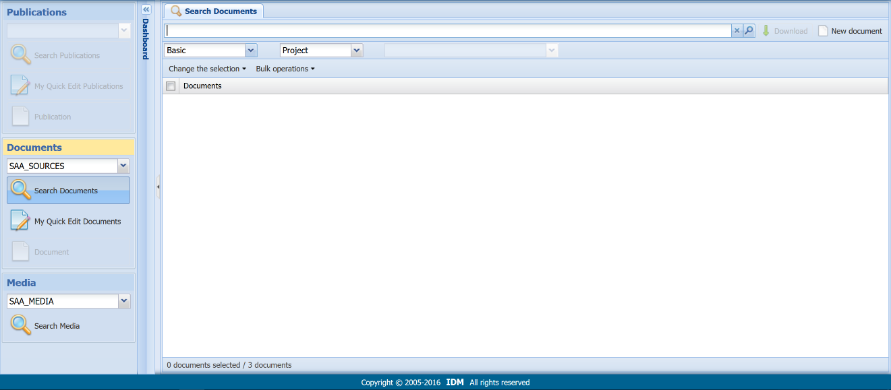

- Click on the “New Document” icon at the upper-right corner of the page.

- In the “Template” field, select “entry.”

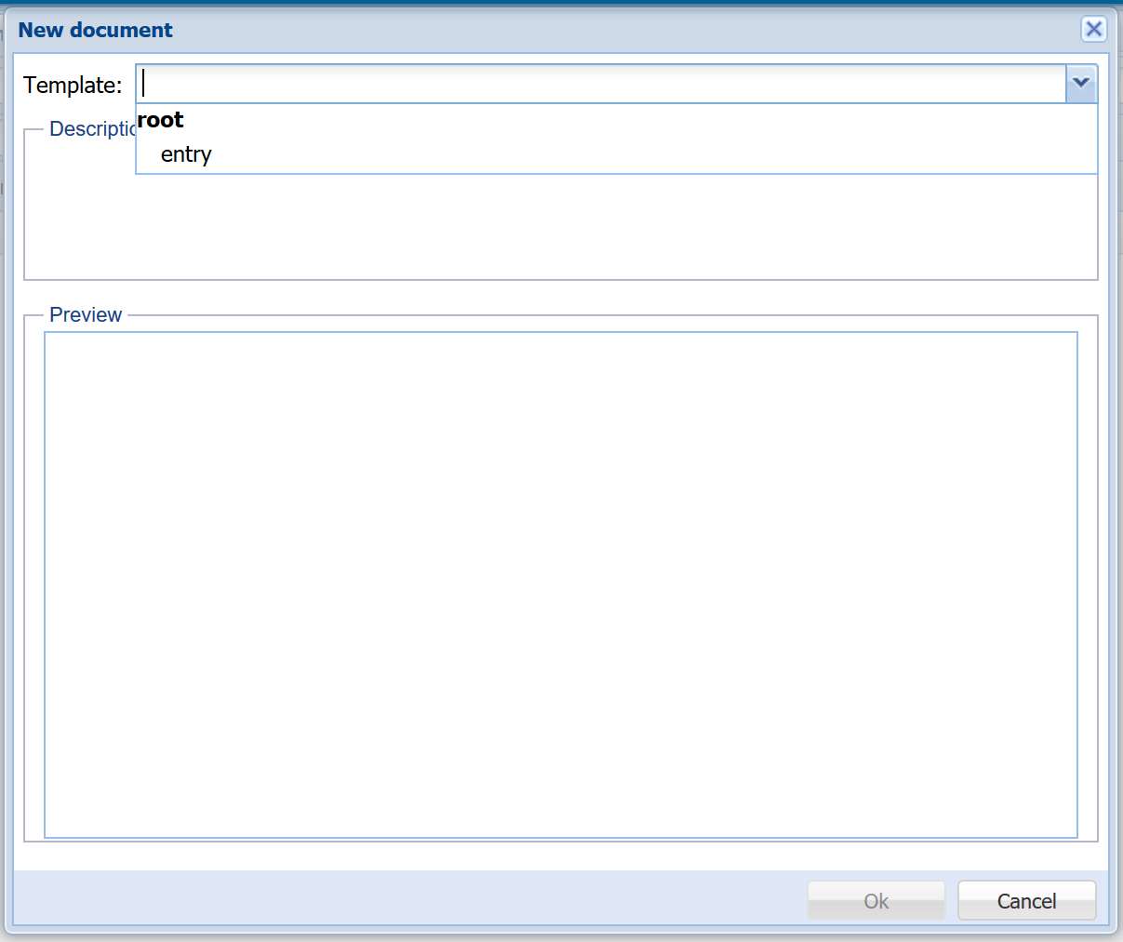
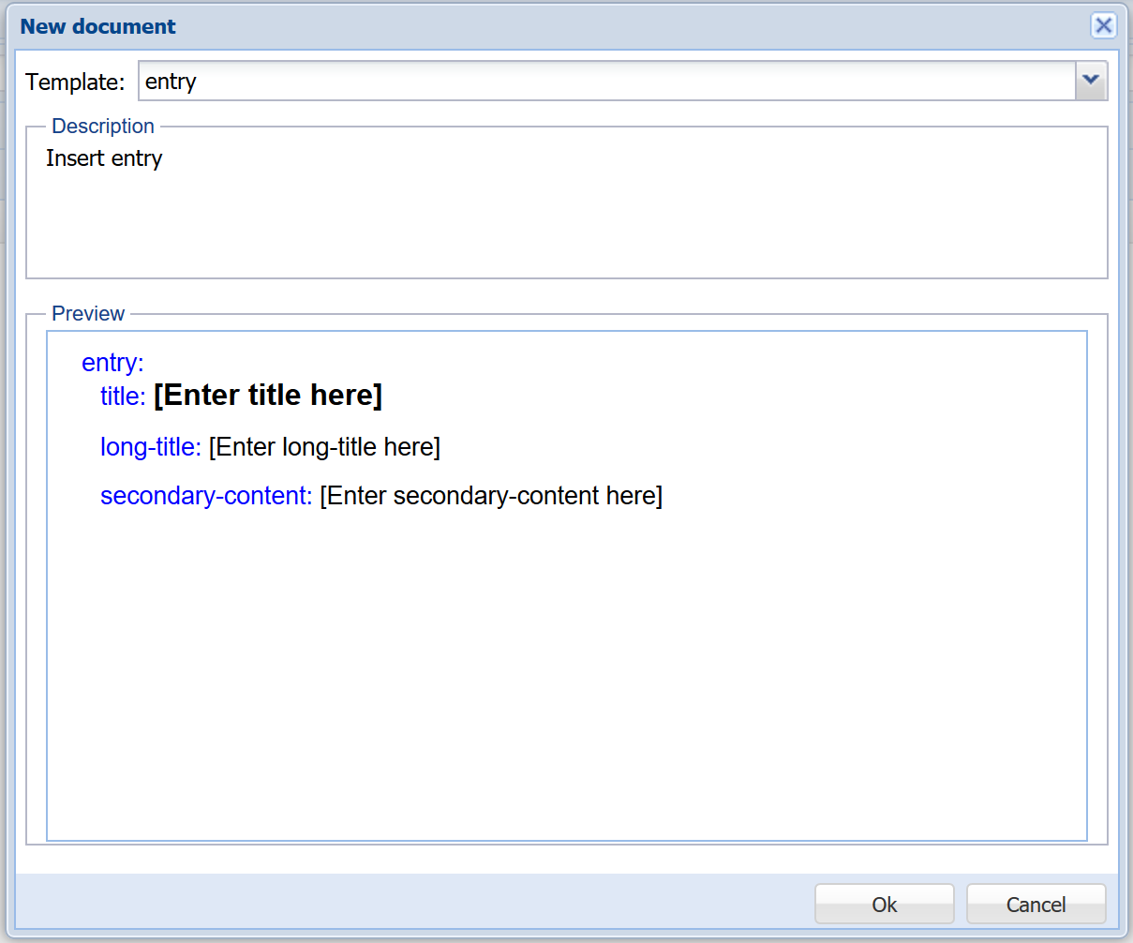

- After ensuring the template looks correct, click “Ok.”

- In the “title” field, type the last name of author(s) and year of publication.

In the “long-title” field, type the full reference for the citation according to the SAA style guide. (See Sources in the Style Guide for a complete explanation and examples.)

In the “secondary-content” field, add the web-based uniform resource locator (URL) of the resource, if applicable. Use of a persistent URL is preferred. If a digital object identifier (DOI) is available, use the DOI instead.

For instance, this is the full bibliographic entry for an article:

Hughes, Charles, Jr., “The Philadelphia Program,” The American Archivist 21:2 (April 1958).

The full URL for the online version of the article is

http://americanarchivist.org/doi/pdf/10.17723/aarc.21.2.9705270181482k23

However, since this URL includes a DOI is available, list only that DOI:

doi/pdf/141.10.17723/aarc.21.2.9705270181482k23

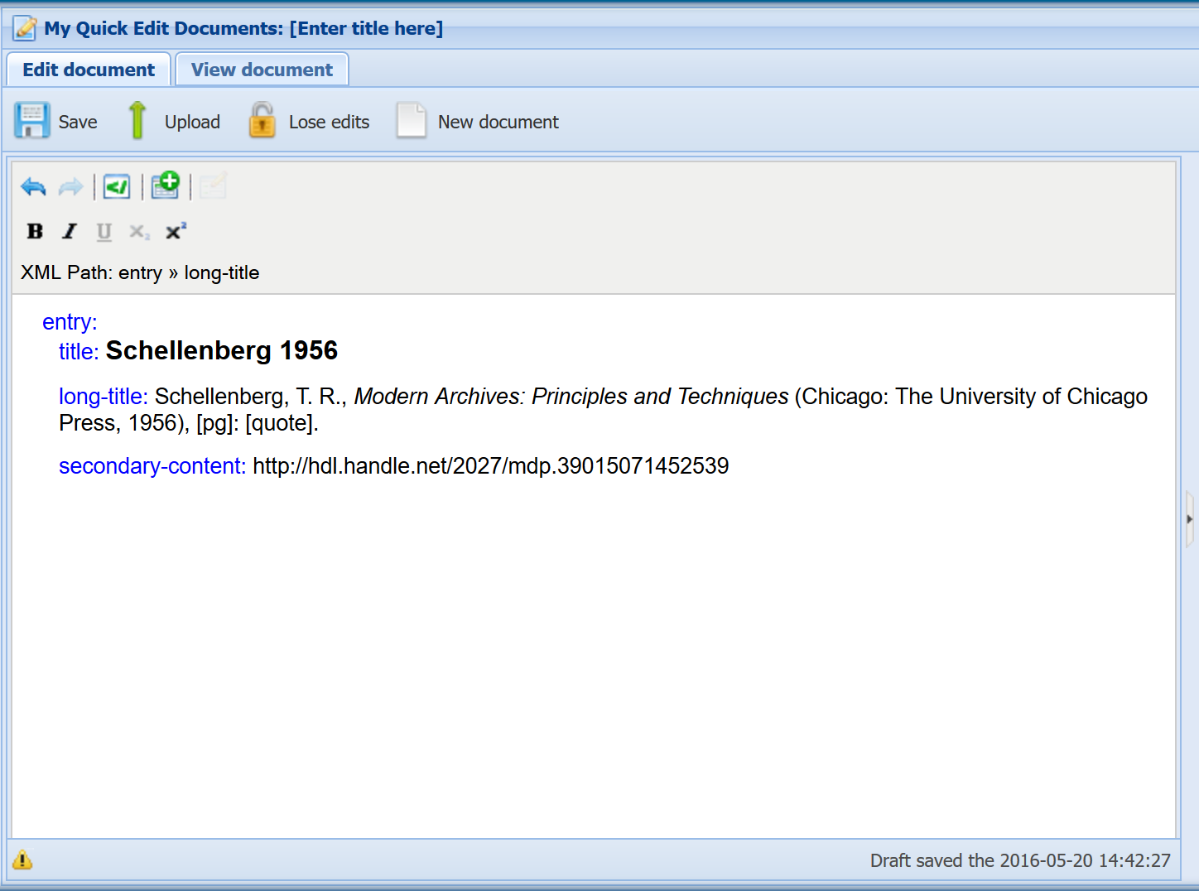

- Finally, click on the “Upload” icon.

Versioning

The Dictionary of Archives Terminology is an online reference work that the Society of American Archivists will update at least once a year. It is an online reference to allow for flexibility in editing and updating and for ease of access to archivists and others across the United States of America and the world.

Although DAT itself is not a fixed and unchanging resource, the Society of American Archivists will ensure the fixity of versions by capturing each separate instance of the dictionary, which will be stored by SAA’s own archives at the University of Wisconsin, Milwaukee.

Different iterations of the dictionary will be identified by the year of its posting and the version that is sequential through a single calendar year. We use the following version numbers as a possible example of how the version numbers might be employed in practice:

2016.1
2017.1
2017.2
2017.3
2017.4
2018.1
2018.2
2018.3
2018.4
2019.1
2020.2

In this example, we assume that only one version, the initial beta version, is release in 2016, and near enough to the end of the year that no other version is released. This example also assumes it will take a couple of additional years to clean up all extant entries while adding new entries and new senses to existing entries. After these two years, however, updates will be much less common, possibly only once a year.

This example is merely that. The Society of American Archivist’s Dictionary Working Group will release updates at whatever point it decides is reasonable, given particular circumstances at the time.

DPS 4 Documentation: Getting Started with the Online Editor

Edmund Wright
Version 1
2015.09.21

Logging in

Procedure

- In your web browser, navigate to the Online Editor URL. This loads the login screen:

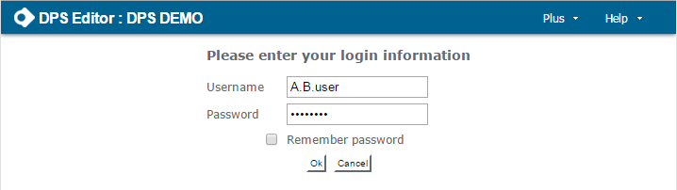

- Enter your username and password in the appropriate fields and click “Ok”.

- If your login is successful, the Online Editor will be loaded.

Prerequisites

Your DPS administrator will have provided you with

- A DPS user name.
- A password.
- The Online Editor’s URL (this is usually something like https://your.DPS.platform/dps-online-editor).

If you cannot log in, it is probably because your DPS access permissions have not been set correctly. Please contact your DPS administrator.

Working with Documents

Finding and Downloading Documents

In the Dashboard

- Select the project containing the document(s) you wish to work with.

- Click the “Search documents” button to display the Search documents tab.

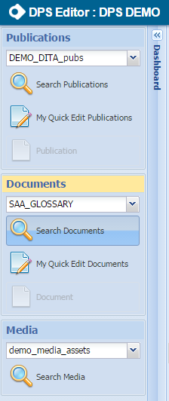

In the Search Documents Tab

To find documents

- Select a search mode.

- Enter a search term.

- Click the “Search” button or press the “Return” key.
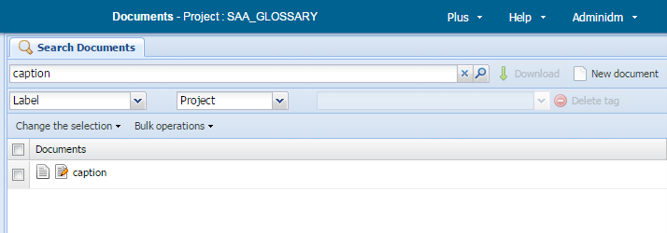

Note: the search context dropdown defaults to “Project”; normally there is no need to change this.

To view documents

- Click the view document icon in the results list:

- This opens a new read-only tab that displays the document content: see Viewing documents.

- You can view several documents at the same time, each in its own tab.

To download documents to your personal workspace

- In the results list, select the documents you wish to download.

- Download selected documents by clicking the “Download” button.

- Work with the documents in your personal workspace.

To open a single document for editing

- Click the view document icon in the results list:

- This downloads the document to your personal workspace and opens it in the document editor: see Editing documents.

- Note: for a single document this procedure is significantly faster than downloading it and then opening for editing from your personal workspace.

Explanation

Search Modes

The online editor gives you three ways to find documents:

- Label (default): Searches are conducted on the documents’ labels. A document’s label is usually its title.

- Basic: Searches are conducted on the documents’ content.

- Advanced: Searches are conducted on any combination of the documents’ labels, content, and other information held by DPS.

Advanced searches are beyond the scope of these instructions.

Search Terms

In Label Mode

Enter the desired document title; to find more than one document, use wildcards. The characters “?” and “*” are treated as wildcards, with their standard meanings:

- ? matches any single characters: b?nd will find “band,” “bend,” “bind,” “bond,” “bund,” etc.

- * matches any sequence of characters: b*nd will find all the above and also “background,” “behind,” “beyond,” “blend,” “blind,” “bound,” etc.

In Basic Mode

To find all documents that contain a word or phrase, specify that word or phrases as the search term: beyond belief will find all documents containing the phase “beyond belief.”

Basic mode is capable of much more powerful searches than this by using the skXML query language. For full details of skXML, see http://dps.cw.idm.fr/index.html, section Features for Advanced Users/SkXML, and Corpora.

Selecting Documents

Documents may be selected in two ways:

- By clicking on the appropriate tickbox. Clicking once selects the document (the tickbox is ticked); clicking again deselects it (the tickbox is empty).

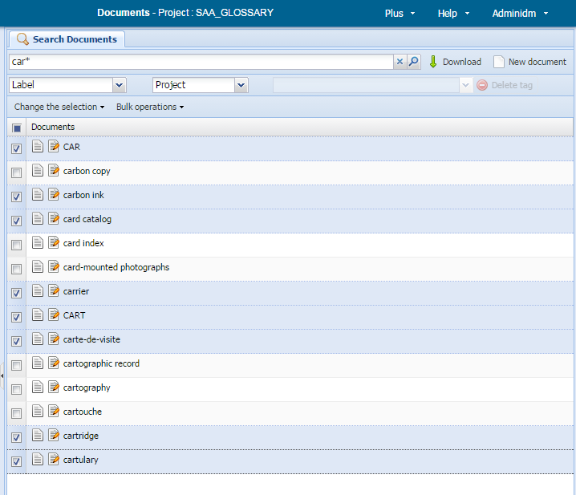

- By choosing one of the options in the menu “Change the selection”:

Option | Description
Select all | All documents in the results list are selected.
Inverse selection | All previously selected documents are deselected; all previously unselected documents are selected.
Select all locked | All documents locked for editing (by any user) are selected.  See downloading documents for an explanation of locking.
Select all unlocked | All documents not locked for editing are selected.
Select all assigned | These options are related to DPS workflow features, which are beyond the scope of this document.
Select all unassigned
Select all in batch
Select all not in batch

Downloading documents

Clicking the “Download” button performs the following actions for each selected document:

- A copy of the document is added to your personal workspace (see Managing your personal workspace for details about the personal workspace).

- If the document is currently unlocked (i.e. it is currently not downloaded by anybody else):

  - The copy in your workspace is editable.

  - The copy in the central repository is locked by you: nobody else may edit it until you unlock it.

- If the document is currently locked by somebody else (because they have downloaded it for editing):

      - The copy in your workspace is read-only; you cannot change it.

  - The copy in the central repository remains locked to the other person.

The net effect of these rules is that, while you may always download any document, only one person can edit a particular document at any one time.

Advanced features

The features outlined below are advanced features that are beyond the scope of this documentation.

Bulk operations

The “Bulk operations” option in the toolbar allows you to perform the same operation on all selected documents.

Search context

Normally searches are conducted on all entries in the current project. The search-context dropdown allows you to limit searches to members of tags.

Viewing Documents

Follow the instructions for viewing documents given in Finding and downloading documents.

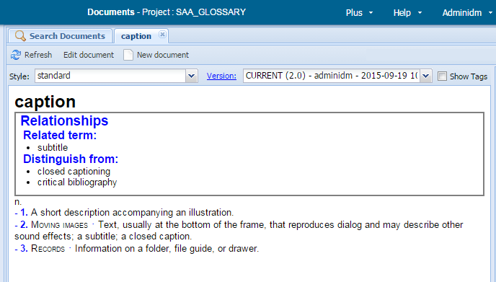

To View the Document with Different Styling

Select a style from the “Style” dropdown.
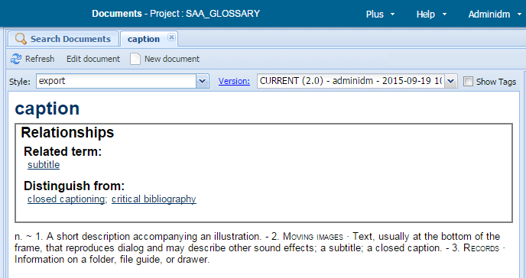

To view Selected XML Tags in the Current Style

Tick the “show tags” tickbox.

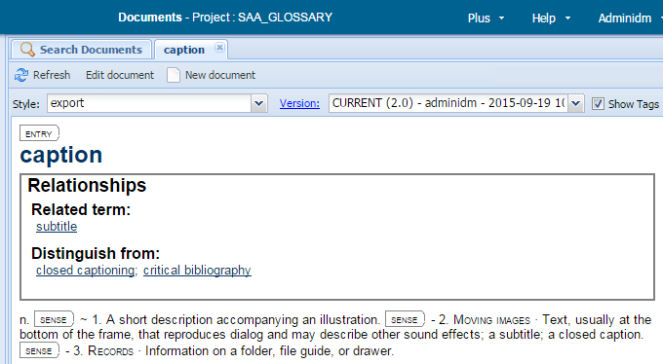

Notes:

- Not all tags are shown. Only important divisions of the document are displayed.

- This option is not available for all projects.

To edit a Document

- Click on the “Edit document” button in the toolbar.

- The document’s current version is downloaded to your personal workspace and opened for editing.

Note: the current version is always downloaded, no matter which version you are viewing.

Working with Document Versions

When you first open a document for viewing, its current version is displayed.

To display a list of document versions

Click the “Version:” button. This displays the document’s version table.

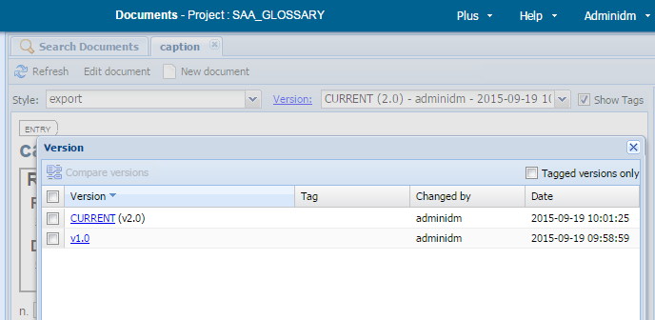

To view an earlier version

Either

- Select the desired version for the versions dropdown.

Or

- Display the version table.

- Click on the version number you wish to view.

When you view a version that is not the current version:

- The banner displays the warning message:

You are viewing an old version of this document.

- These additional options are available:

- Compare with current version: compares the version you are viewing with the current version.

- View current version: reverts to viewing the current version.

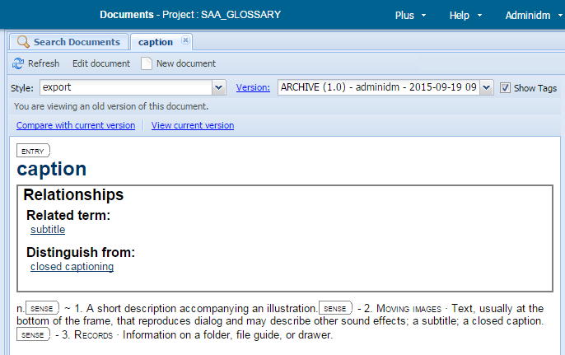

To Compare Two Document Versions

- Display the version table.

- Select two versions.

- Click the “Compare versions” button.

If version Y is compared with an earlier version X:

- The differences are shown in a style that displays all XML tagging. No other styles are available.

- Content deleted from version X to create version Y is shown on a red background.

- Content added to version X to create version Y is shown on a green background.

- Content that is unchanged between X and Y is shown on a white background.

- The banner displays the line:

Versions compared: X vs Y
Clicking on X or Y will display that version.

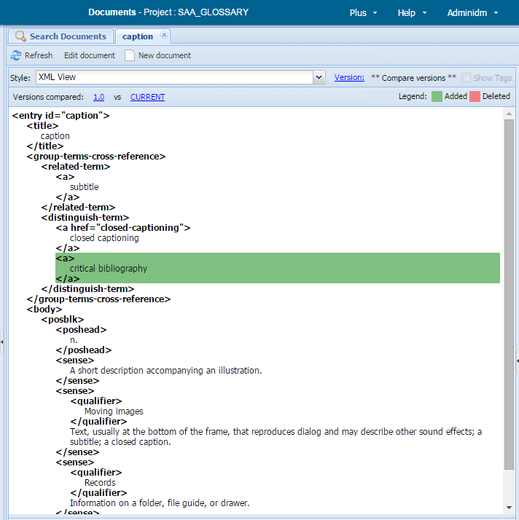

Explanation

Styles

Each DPS document project provides one or more display styles to display documents in different ways. For example:

- A WYSIWYG view as close as possible to a proposed output format (e.g. a webpage).

- Another WYSIWYG view to emulate a different output format (e.g. in print).

- Styles that focus on particular parts of a document by suppressing other parts.

- Styles that show some or all XML tagging.

The minimal configuration is one style, usually a WYSIWYG view. A style to show all XML tagging is usually also available.

Version Table

The version table displays this information for each version of a document:

- Version: the version number, in the form “vX.0.”

  - Exception: the current version is labeled “CURRENT (vX.0).

- Tag: if the version is a member of any tags, they are listed here.

A DPS tag is a collection of document versions. Tag usage is beyond the scope of this document.

- Changed by: the user name of the person who created the version.

- Date: the date and time the version was created.

Managing Your Personal Workspace

In the Dashboard

- Select the project containing the document(s) you wish to work with.

- Click the “My Quick Edit Documents” button to display your workspace.
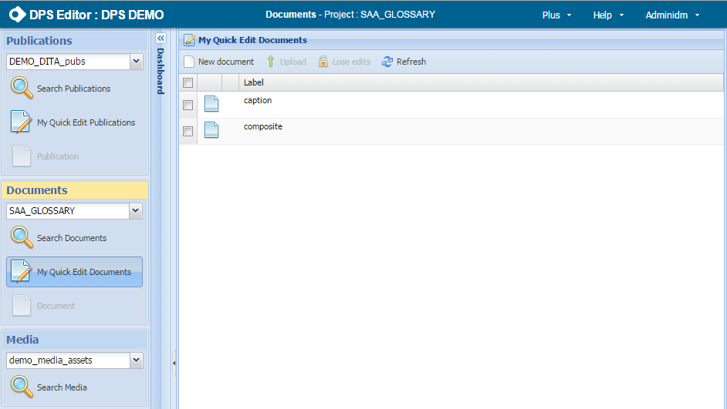

In the Workspace

To Edit a Document

In the document list, click on the relevant document’s label. The document is opened for editing: see Editing documents. (Note: only one document may be open for editing at any time.

If another document is already open, you will be prompted to save any changes and it will be closed.)

To Upload a Modified Document to the Repository

- Select the document(s) you wish to upload.

- Click the “Upload” button.

To Remove a Document from the Workspace without Uploading

- Select the document(s) you wish to remove.

- Click the “Lose edits” button.

To Create a New Document

- Click the “New document” button.

- The new document popup is displayed. Choose a document type and click the “Insert” button.

- A new document of the selected type is created and opened for editing. (Note: only one document may be open for editing at any time. If another document is already open, you will be prompted to save any changes and it will be closed.)

Explanation

The Workspace

Your workspace lists all the documents in the current project you have downloaded from the central repository. You have a separate workspace for each project.

As explained in Finding and downloading documents, documents you download are either editable (and locked by you in the central repository) or read-only (because they are locked by somebody else). These are distinguished by their icons:

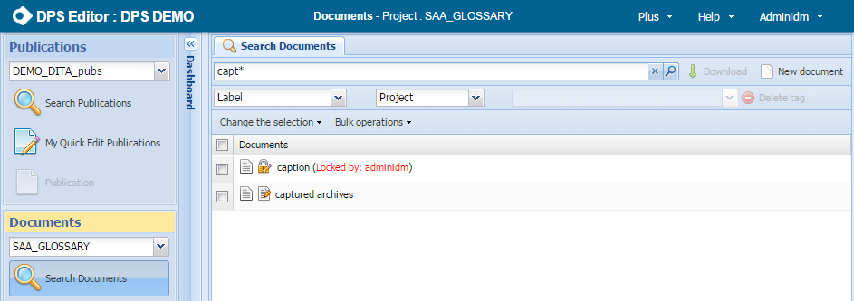

Note that a document’s editable/read-only status is determined when it is downloaded. If a read-only document is subsequently unlocked in the central repository, it does not become editable in your workspace. Your must remove it from your workspace and download it again to make it editable.

Selecting Documents

Documents can be selected in two ways:

- By clicking on the appropriate tickbox. Clicking once selects the document (the tickbox is ticked); clicking again deselects it (the tickbox is empty).

- By clicking on the master tickbox in the document list’s title row. This selects/deselects all documents in the workspace.

Uploading Documents

When selected document(s) are uploaded by clicking the “Upload” button:

- If one of the selected documents is currently open for editing and has unsaved changes, you will be prompted to save those changes.

- New versions of all the selected documents are created in the central repository. These new versions contain all changes you have made in the Online editor since you downloaded the documents.

- The selected documents are unlocked in the repository.

- The selected documents are removed from your workspace.

Some documents cannot be uploaded:

- (Always) Read-only documents. Attempting to upload such documents has no effect.

- (Sometimes) Documents with DTD errors. Projects can be configured to accept uploads of documents with DTD errors or to reject them. In the latter case attempting to upload such documents gives an error. You must deselect such documents before any of the selected documents can be uploaded.
Note: even if you project permits uploads of documents with DTD errors, it is best practice not to upload documents until all such errors have been fixed.

Removing documents from the workspace

When selected document(s) are removed from the workspace by clicking the “Lose edits” button:

- If one of the selected documents is currently open for editing and has unsaved changes, you will be asked whether you want to lose those changes or to cancel the operation.

- If one or more of the selected documents has been modified since you downloaded it, you will be asked whether you want to lose those changes or to cancel the operation.

- The selected documents are unlocked in the repository.

- The selected documents are removed from your workspace.

All documents – editable, read-only, with or without structural errors – can always be removed from the workspace.

New document popup
The new document popup is displayed when you create a new document:

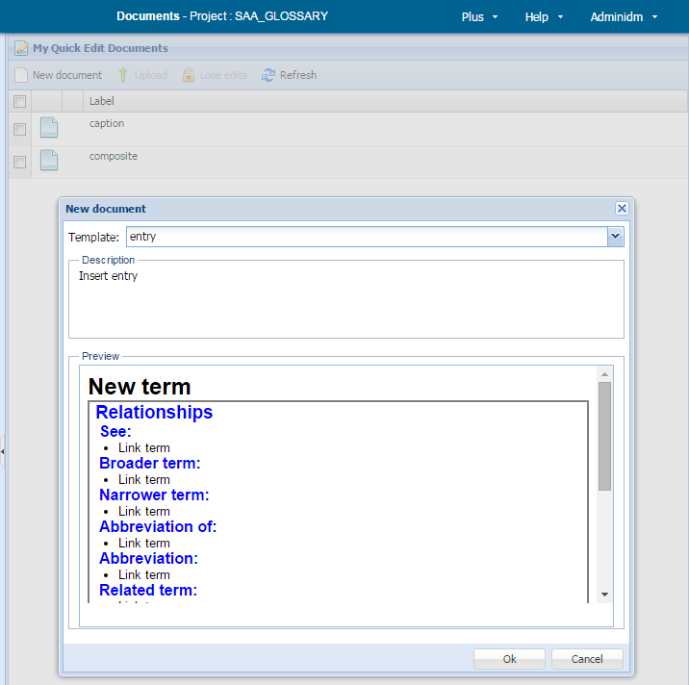

The “Template” dropdown lists all the document types available for the current project. When you select a document type:

- The “Description” panel contains a brief description of that document type.

- The “Preview” panel shows a framework for that document type. This contains common features and placeholder text. When the document is created, its initial content is this framework.

Other workspace features

Highlighted document

If a document is open for editing, that document is highlighted in the workspace:

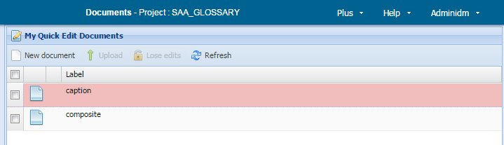

DTD errors indicator

DPS keeps track of whether each document’s XML content conforms to its project’s DTD or Schema. If it does not conform, the DTD errors indicator is displayed against its entry in the workspace document list:

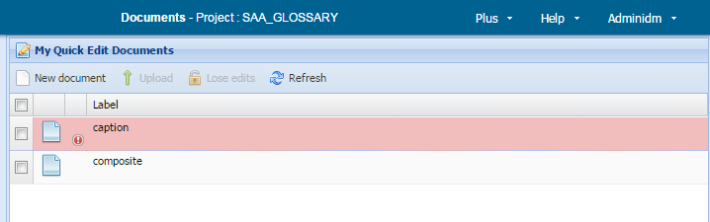

If you click on a DTD errors indicator, the relevant document is opened for editing and a list of DTD errors is displayed. See Editing documents for details on how to correct DTD errors.

Draft saved indicator

When a document is open for editing, a draft is saved every two minutes. The Draft saved indicator against a document’s entry in the workspace document list shows that a draft has been saved for that document. See Editing documents for details on how drafts are used.
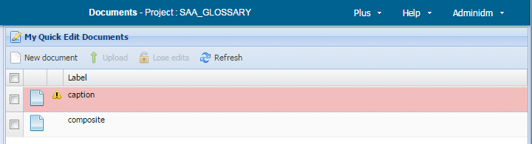

Editing Documents

In the Dashboard

- Select the appropriate project.

- Click the “Document” button to display the document currently opened for editing.

Note: the document button is enabled only if a document has been opened for editing in the selected project as described in Managing your personal workspace.

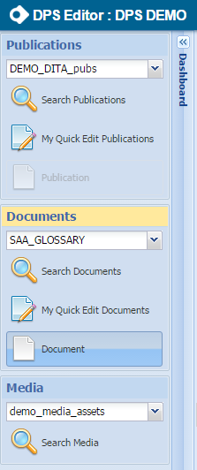

In the Edit Document Tab

The “Edit document” tab gives a WYSIWYG-like view of the document currently open for editing. It is where all document editing takes place.

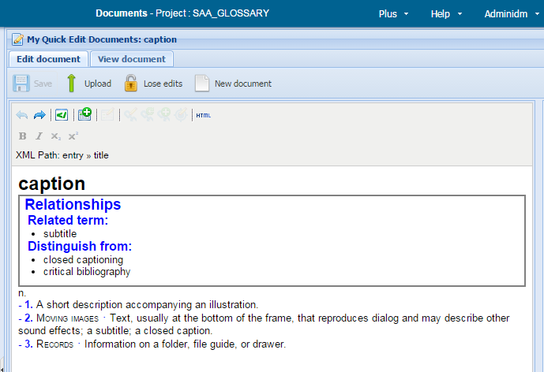

To Find Your Way around the Element Structure

- Click on the relevant part of the text to place the cursor.

- Alternatively, use the arrow keys to move around the document.

- The XML Path display will update to show your position in the document’s element structure. It will continue to update as you move the cursor.

- If you select an element, the text cursor is moved to encompass that element.

To Modify Text within an Existing Element

Use the keyboard keys and mouse to type text, delete text, cut/copy-and-paste, undo changes, etc., in the same way as you would in a word processor. Most common keyboard shortcuts have their usual meanings; see here for a list of useful shortcuts

Note: the content of some elements is not editable by these means. In general the text cursor cannot be placed within such elements and the cursor movement (arrow) and delete keys will skip over them.

To Style Text

These styles can be applied to text using buttons in the toolbar or keyboard shortcuts:

- Bold

- Italic

Notes:

- In general this form of styling should be used to highlight individual words or phrases, not to create titles etc. Most XML elements are configured to generate an appropriate style, so ensuring that your document is structured correctly will lead to the correct styling. Turning this round the other way: incorrect styling probably means incorrect document structure. Correct bad styling by correcting the document structure, not by patching it with ad-hoc bold, italic, etc.

- The precise list of available styles might vary according to the current project’s configuration

To Select an XML Element

- Place the cursor within the element.

- Click on the element’s name in the XML path display.

To Delete an XML Element

- Select the required element.

- Press the “Del” button.

To Cut-and-Paste an XML Element

- Select the required element.

- Cut or copy the element (control-X or control-C).

- Place the cursor at the desired position and:

- Press control-V to paste. The cut content is pasted at this position, but all XML tags are stripped out.

- Alternatively, select an element in the XML path, then press control-V to paste. A cut-down version of the template picker is displayed, allowing you to choose where to paste the cut content relative to the selected element:

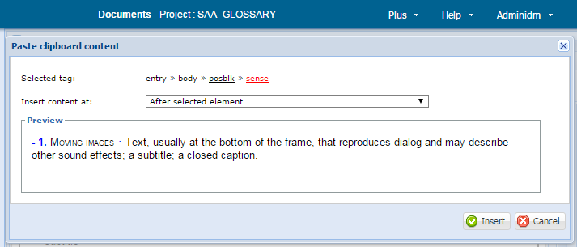

In this paste mode the XML tagging in the cut data is preserved. Note: you will only be allowed to paste the cut content in locations where it is allowed by the DTD.

To Insert a Template

- If the template is to be inserted at a precise position, place the text cursor at that position. If the template is to be inserted before, after, at the start of, or at the end of an element, place the text cursor somewhere within that element.

- Open the template picker, either by clicking the “Insert a template” button or by pressing the “Return” key.

- In the template picker, specify:

  - Selected tag: which element in the current XML path to use as the reference element for positioning the new template. Default: if a whole element has been selected, that element; otherwise, the innermost element.

  - Insert template at: where to insert the template relative to the selected element. Available options are

- After selected element.

- Before selected element.

- Start in selected element.

- End in selected element.

- Cursor position in selected element (not available if a whole element has been selected).

  - Template: the template to insert. Only templates that are valid at the selected position are shown.

- Click the “Insert” button.

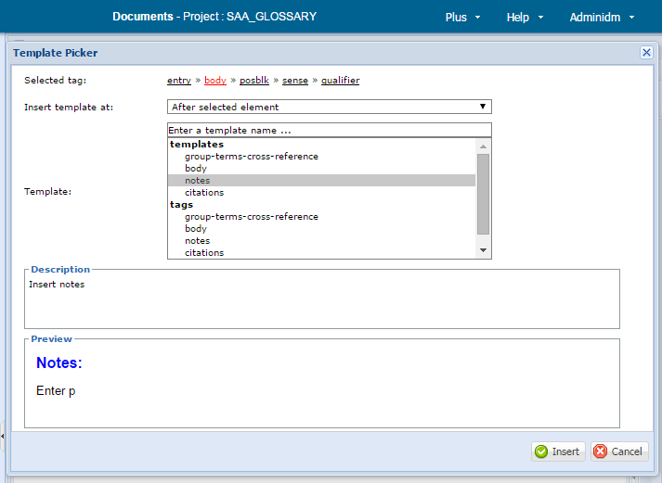

Keyboard shortcuts for the template picker

Shortcut | Action
Tab | Move to the next field requiring user input
Shift-Tab | Move to the previous field requiring user input
Control-S | Selects the ‘Selected tag’ field. You can change the selection with the left- and right-arrow keys.
Control-O | Selects the ‘Insert template at’ field. You can now:  - Use Alt-up-arrow or Alt-down-arrow to open the dropdown list.  - Use the up-arrow and down-arrow keys to change the selection.  - Typing letters will progressively select the first option that starts with those letters.
Control-M | Selects the ‘Template’ field, You can now:  - Use the up-arrow and down-arrow keys to change the selection.  - Typing letters will progressively select the first element that starts with those letters.

To edit an element’s attributes

- Place the text cursor within the relevant element.

- Open the attribute editor by clicking the “Edit attributes” button.

- In the attribute editor, specify:

  - Selected tag: which element in the XML path you wish to edit. Default: the innermost element.

  - Namespace: the XML namespace of the attribute to be edited.

  - Name: the name of the attribute to be edited. Select this from a dropdown list of valid attributes for the selected element in the selected namespace.

  - Alternative to steps 3b and 3c: select the Namespace and Name by clicking the appropriate entry in the Attribute/Value table (below the “Value” field).

  - Value: the current value is initially displayed. Either

- Enter the desired new attribute value.

- Click the “Remove” button to remove the attribute altogether.

The new value is shown in the Attribute/Value table. This table shows the value of all possible attributes of this this element.

- Step (3) can be repeated to edit other attributes.

- When all attributes have been set to the desired values, click the “OK” button. This records your changes; no changes are made to the document data until “OK” is clicked.

Alternative to steps 3 and 4: edit attribute values in the “Value” column of the Attribute/Value table.

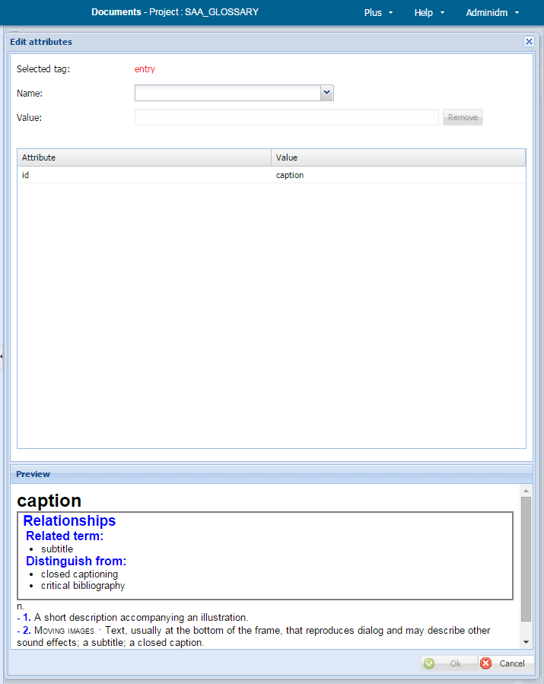

To Insert a New Cross-reference

- Place the cursor where you wish to insert the cross-reference: either place it in textual content or select a whole element.

- Click on the “Create cross-reference” button. This displays the create cross-reference popup.

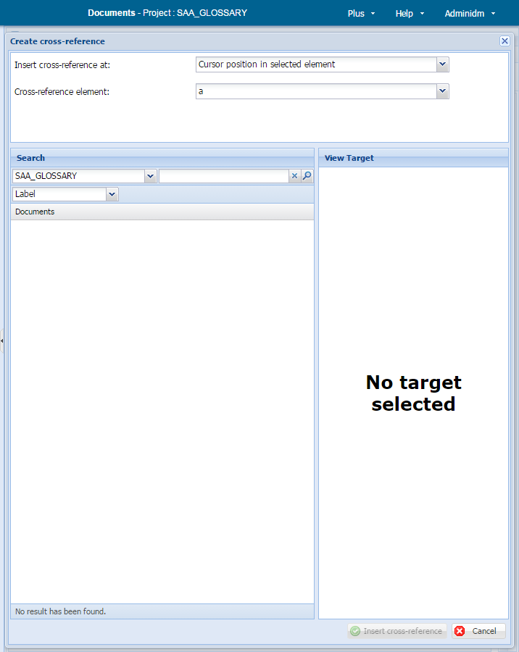

- Select the position to insert the cross-reference:

- Start in selected element.

- End in selected element.

- Cursor position in selected element (not available if a whole element has been selected).

- Select the cross-reference element you wish to insert. The available options will vary according to your project’s DTD.

- Search for the target document in the “Search” panel:

- Select the project that contains the document.

- Select the search mode.

- Specify a search term consistent with the selected search mode.

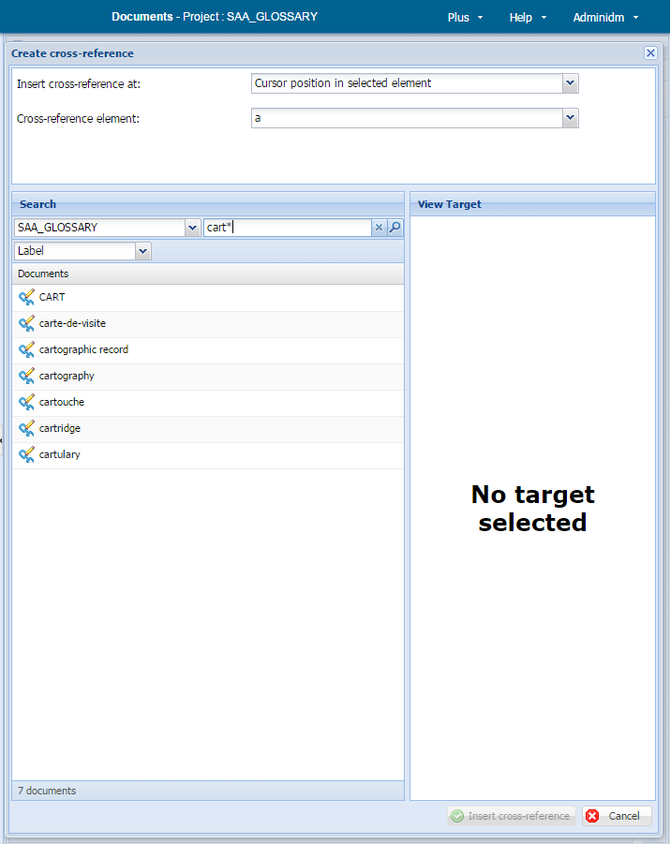

- Select the desired document from the result list by clicking on its cross-reference icon:

- The document’s content is displayed in the “View target” panel. If it is not the correct document, you can pick another from the result list or run a new search.

- Select the desired target element within the document. Only valid target elements are shown:

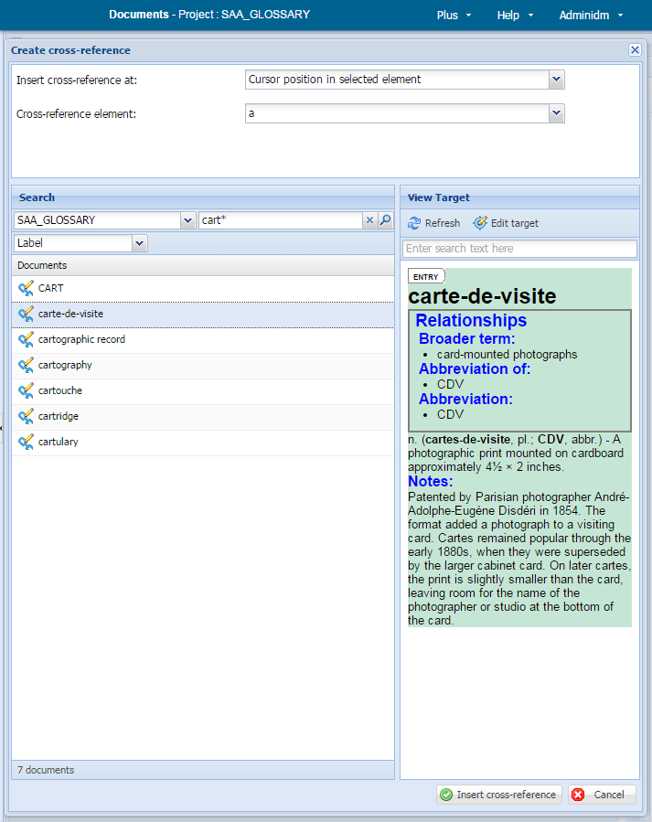

- Click the “Insert cross-reference” button.

To Edit an Existing Cross-reference

- Click on a cross-reference to select it.

- Open the cross-reference editor by clicking on the “Edit cross-reference” button. The current target document is opened in the “View Target” panel.

- If necessary, search for a new document in the “Search” panel.

- Select the desired target element within the document.

- Click the “Update cross-reference” button.

To Update a Cross-reference

- Click on a cross-reference to select it.

- Update the cross-reference by clicking on “Update cross-reference” button.

Note: this option is not generally useful because DPS automatically keeps the content of cross-reference elements up-to-date. Only use it to refresh links where you know the target document has changed but the cross-reference has not been updated.

To Edit the Target of a Cross-reference

- Click on a cross-reference to select it.

- Click on the “Edit cross-reference target” button.

- If the open document has unsaved changes, you will be prompted to save them.

- The target of the cross-reference is downloaded to your personal workspace and opened for editing. The target element of the cross-reference is selected.

To Correct DTD Errors

If a document has DTD errors, the DTD errors indicator will show in the status bar at the bottom of the editing panel:

- Click on the DTD errors indicator to open the validation report, which displays a list of errors. (Note: a single problem in the data may produce more than one DTD error.)

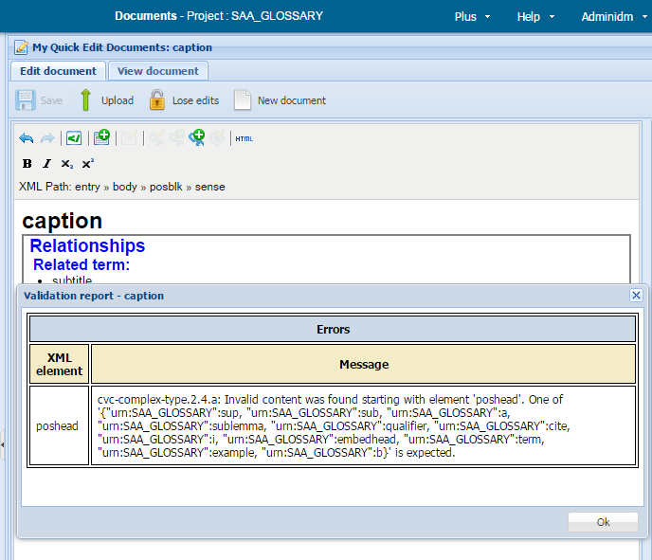

- Click on an error to select the element containing the problem.

- Correct the problem. (Note: you can edit the document content without closing the validation report.)

- When you have finished correcting errors, close the validation report by clicking “OK”.

- Save the document to re-validate it.

- If all problems have been resolved, the DTD errors indicator will vanish. If it is still displayed, there are still some DTD errors; repeat these steps. until all problems are resolved.

To Save Changes

- Click the “Save” button to save changes you have made to the document.

Note: these changes are saved only in the copy of the document in your personal workspace. The master copy of the document in the central repository is only changed when you upload the document.

To Upload the Open Document to the Repository

- Click the “Upload” button to upload the document to the central repository.

- Note: this is the same functionality as the “Upload” button on the personal workspace page.

To Remove the Open Document from Your Workspace

- Click the “Lose edits” button to remove the document from your personal workspace.

Note: this is the same functionality as the “Lose Edits” button on the personal workspace page.

To Recover Unsaved Changes

If you open a document for editing that has an unsaved changes:

- You will be asked to choose between

(a) reverting to the last saved version (the so-called “current version”) or

(b) keeping your unsaved changes

You cannot edit the document until you have made this choice.

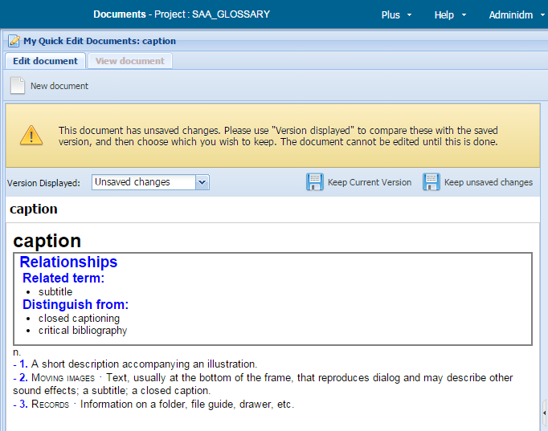

- You can view both the saved version and the unsaved changes by selecting one from the “Version displayed” dropdown.

- Choose the one you want by clicking either the “Keep Current Version” button or the “Keep unsaved changes” button.

- Your choice will then open in the editing panel.

In the View Document Tab

The “View document” tab provides alternative views of the document currently open for editing. It is the same feature as described in “Viewing documents“ with these differences:

Additional Version “DRAFT”

There is an additional version, “DRAFT”, available in both the version dropdown and the version table. This is the version you are currently creating in the online editor and includes all your changes, both saved and unsaved. It can be compared against any previous version.
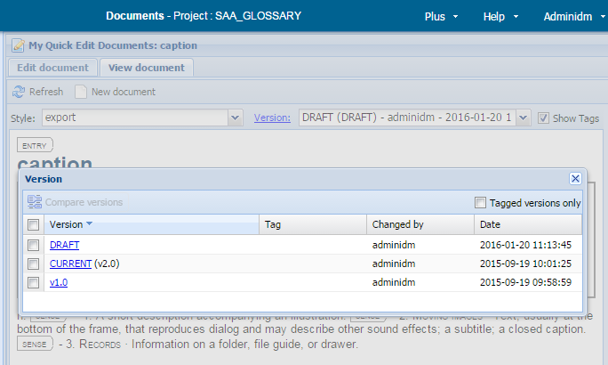

To Roll Back to a Previous Version

- Open the version table.

- Click to display the version you wish to roll back to. This can be any version other than DRAFT.

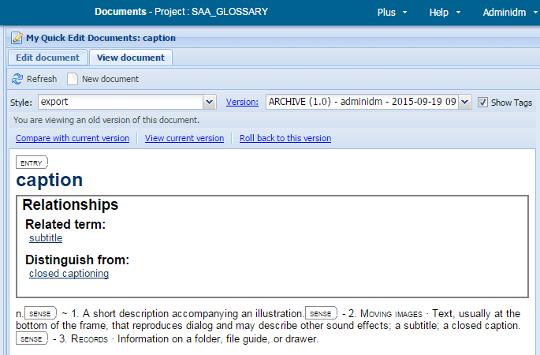

- Click the button “Roll back to this version.”

- A popup displayed:

  - Choose whether to roll back only XML content, only metadata and categories, or both (default).

  - Confirm the rollback by clicking the popup’s “Roll back to this version” button.

The draft version is discarded and a new one created from the content of the selected version. This new draft is saved in your personal workspace. It can be revised and uploaded as normal.

Explanation

Useful Keyboard Shortcuts

Shortcut | Action | Notes
control-X | Cut | Standard meaning
control-C | Copy | Standard meaning
control-V | Paste | Standard meaning
control-Z | Undo | Standard meaning
control-Y | Redo | Standard meaning
Return | Opens the template picker
control-Return | Split current element at cursor | For example: if the cursor is located within a <p> (paragraph) element, after control-Return is pressed there will be two <p> elements. If the cursor is at the beginning/end of an element, control-Return is a good way of creating a new empty instance of the same element before/after the current element.

XML Path

The Onlined Editor is a WYSIWYG editor, so a document’s XML tags are not displayed. However, for some operations it is important to know where you are in the document’s structure. The XML path shows the current location of the text cursor in the document structure. This path

Means

- The text cursor is located in a “sense” element.

- That “sense” element is contained within a “posblk” element.

- That “posblk” element is contained within a “body” element.

- That “body” element is contained within a “entry” element.

The left-most element in an XML path is always the element that encloses the whole document, so it never changes.

Templates

Templates are predefined units of XML structure that allow you to add new content to your document. Each template has a name that describes its purpose: for example, a template called “sense” will insert into your document all the necessary XML elements for a new sense.
In the Online Editor templates are the recommended way to add new content to your document. They ensure the correct XML structure is inserted in the correct place, thus avoiding DTD errors.

Templates consist of

- An XML element, possibly with sub-elements.

- (Usually) Some textual content: either standard text or prompts that show you where to enter textual content.

For example, the template “sense” might insert the XML element(s) for a new sense and also the prompt “Enter sense”. Replace “Enter sense” with the genuine text for the sense.

Cross-references

The content of cross-reference elements is managed by DPS and cannot be edited by users. When the desired target has been specified, DPS computes the content of the cross-reference by extracting data from the target according to pre-configured rules. This will usually be the document’s label, but possibly also additional data: for example, a subtitle if the cross-reference target is a sub-section of the target document. If target document is modified, DPS automatically updates the content of all cross-references linked to that target document.

Document Versions

DPS maintains a full version history of all documents. Once saved in the central repository, versions are never overwritten: when you upload a document, a new version is created.
The latest version of a document in the repository is called the current version; all earlier versions are called archive versions.

Normally you work with the current version: when you download a document, it is the current version that is downloaded. The online editor also maintains a draft version in your personal workspace of all downloaded documents; this contains the changes you have made in the online editor. When you upload a document, the online editor sends the draft version to the repository, where it creates a new current version.

For example, assume you download version 21.0 (the current version) of document X and make some changes in the online editor. These changes are recorded in the draft version. When you upload the document to the repository, the content of the draft version is used to create the new current version, 22.0.

These rules also apply when you roll back to a previous version; rolling back does not delete any versions already held in the DPS repository. Again, assume you download version 21.0 (the current version) of document X, but then you roll back to version 5.0. If you upload the document without further changes, new version 22.0 is created with the same content as version 5.0; versions 6.0–20.0 remain unchanged. It is never the case that, e.g., versions 6.0–20.0 are deleted and the upload creates a new version 6.0. You are rolling back the document’s content, not its version history.

Unsaved Changes

When a document is open for editing, a snapshot of the draft is saved every two minutes. This minimizes the lost work should the Online Editor close without your changes being saved. When a document is saved (by clicking the “Save”) button, any snapshot is deleted.
When a draft snapshot has been saved, the draft saved indicator is displayed at the bottom of the editing panel:

Snapshots are a safety measure that only become relevant following an error: a computer malfunction, inadvertent closure of the online-editor browser page, etc. As long as everything works properly, you will not need to engage with drafts.

Working with Publications

Working with publications is very similar to working with documents. These instructions for documents also apply to publications:

- Finding and downloading documents

- Managing your personal workspace

- Editing documents

The only difference is in the selections you make in the dashboard: instead of using the buttons etc. in the “Documents” area of the dashboard, use their equivalents in the “Publications” area:

[screenshot: documents and publications areas of dashboard]

These instructions cover additional features that apply only to publications:

- Viewing publications

Viewing Publications

In the Dashboard

- In the dashboard, select a publication from the publications dropdown list.

- In the dashboard, click the “Search publications” button.

[screenshot: dashboard settings for searching publications]

In the Search Publications Tab

- Search for the publication you want: see Finding and downloading documents for instructions on how to do this.

- Click the appropriate document icon in the results list:

[screenshot: document icon]

This opens a new read-only tab that displays the publication content in a tree view:
[screenshot: view publication page]

Note: you can view several documents at the same time, each in its own tab.

On the View Publication Tab

To edit the publication

- Click the “Edit publication” button in the toolbar:
[screenshot: edit publication button]

- The publication is opened in the publication editor. (The publication editor works in the same way as the document editor: see Editing documents).

To select linked documents

Linked documents may be selected in three ways:

- By clicking on the appropriate tickbox. Clicking once selects the document (the tickbox is ticked); clicking again deselects it (the tickbox is empty).

- By clicking on the tickbox of a group header. This selects all linked documents within that group.

- By selecting one of the options in the menu “Change the selection”:

Option | Description
Select all | All linked documents in the publication are selected.
Select none | All linked documents in the publication are deselected.
Inverse selection | All previously selected linked documents are deselected; all previously unselected linked documents are selected.
Select all locked | All linked documents locked for editing (by any user) are selected. See downloading documents for an explanation of locking.
Select all unlocked | All linked documents not locked for editing are selected.

[screenshot: publication view with some nodes selected]

To view linked documents

- Click the appropriate document icon.
[screenshot: document icon]

- A read-only view of that document is opened in a new document tab: see Finding and downloading documents.

To edit linked documents

- Select one or more linked documents.

- Click the “Edit documents” button in the toolbar.

- The selected documents are downloaded into your document personal workspace.

- The last selected document is opened in the document editor.

The Publication View

The publication view displays a publication as a concise tree. Terminal nodes in the tree are links to documents; non-terminal nodes are grouping elements within the publication.

Initially the tree is displayed fully expanded; however, you may collapse/expand non-terminal nodes by clicking on the node’s +/- icon.

Bulk Operations

The “Bulk operations” option in the toolbar allows you to perform the same operation on all selected documents. Bulk operations are beyond the scope of these instructions.

Working with Media

Searching Media Records

In the Dashboard

- Select the media project you wish to work with.

- Click the “Search Media” button.

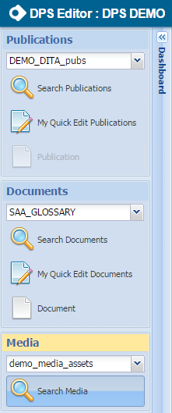

In the Search Media Tab

To find media records

- Select a search mode.

- Enter a search term.

- Click the “Search” button or press the “Return” key.

For each media record that matches the search criteria, the result list shows:

- Its label.

- A preview in a format suited to the type of item: images show thumbnails, sound files and movies display a button that will play the item, etc.

  - Note: previews are not shown in results lists containing more than 50 items.

- A view media icon.

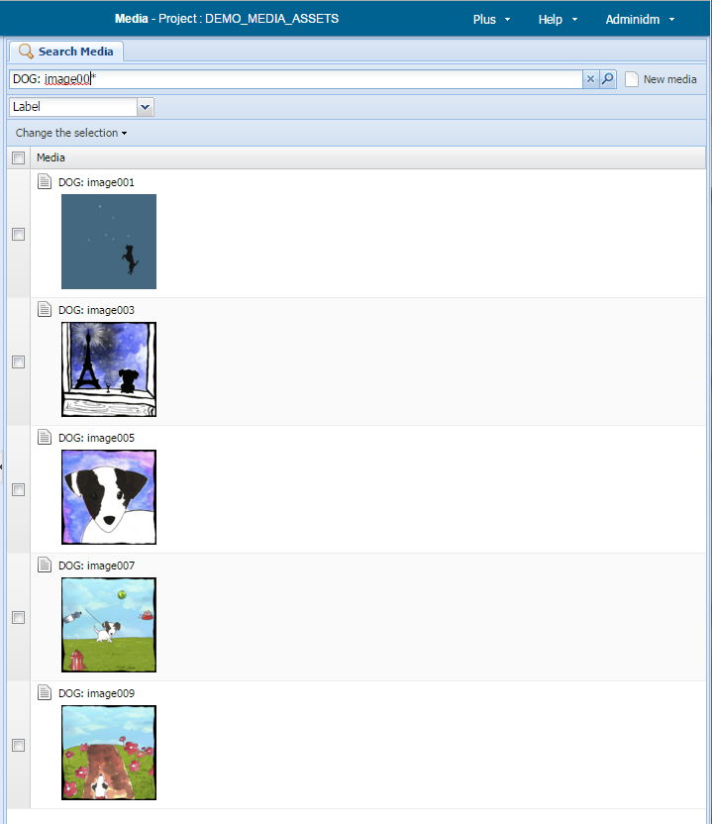

To view media records

- Click the view media icon in the results list:

- This opens a new read-only tab that displays the document content: see Viewing media records.

You can view several media items at the same time, each in its own tab.

To select media records

Use either of these methods:

- Click on the appropriate tickbox. Clicking once selects the media record (the tickbox is ticked); clicking again deselects it (the tickbox is empty):

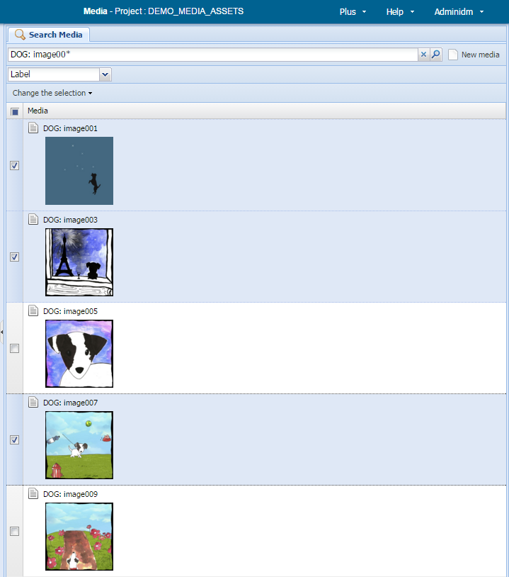

- By choosing one of the options in the menu “Change the selection”:

Option | Description
Select all | All media records in the results list are selected.
Inverse selection | All previously selected media records are deselected; all previously unselected media records are selected.
Select all locked | All media records locked for editing (by any user) are selected.
Select all unlocked | All documents not locked for editing are selected.
Select all assigned | These options are related to DPS workflow features, which are beyond the scope of this document.
Select all unassigned
Select all in batch
Select all not in batch

Media Projects

A media project is a collection of media records. A media record contains all the information associated with a single media item:

- The media item itself. Common media types – JPEG and PNG images, MP3 and OGG audio files, etc. – are recognized and previewed correctly. However you are not limited to these media types: you can store any type of media in a media project. In many cases a media record may define several variants of a single media item; for example, the same image at different resolutions, in different formats, etc.

- Its label: a descriptive title assigned to the media record when it was created.

- Other metadata about the media item: creator, creation date, description, etc.
Internally media projects are a special type of a standard DPS project, so they share a lot of features with document projects.

Search Modes

The online editor gives you three ways to find media records:

- Label (default). Searches are conducted on the media records’ labels.

- Basic. Searches are conducted on the media records’ content.

- Advanced. Searches are conducted on any combination of the media records’ labels, content, and other information held by DPS.

Advanced searches are beyond the scope of these instructions.

Search Terms

In Label Mode

Enter the desired media record’s label; to find more than one media record, use wildcards. The characters “?” and “*” are treated as wildcards, with their standard meanings:

- ? matches any single characters: b?nd will find “band,” “bend,” “bind,” “bond,” “bund,” etc.

- * matches any sequence of characters: b*nd will find all the above and also “background,” “behind,” “beyond,” “blend,” “blind,” “bound,” etc.

In Basic Mode

To find all media records that contain a word or phrase, specify that word or phrases as the search term: South Dock Sunderland will find all documents containing the phase “South Dock Sunderland.”

Basic mode is capable of much more powerful searches than this by using the skXML query language. For full details of skXML, see http://dps.cw.idm.fr/index.html, section Features for Advanced Users/SkXML, and Corpora.

Viewing Media Records

To View a Media Record

Follow the instructions for viewing media records given in Searching media records.
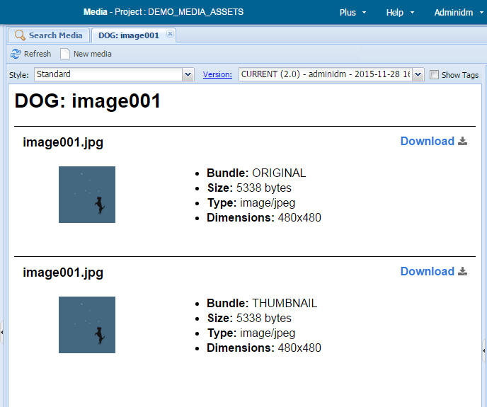

To View the Media Record with Different Styling

Select a style from the “Style” dropdown.
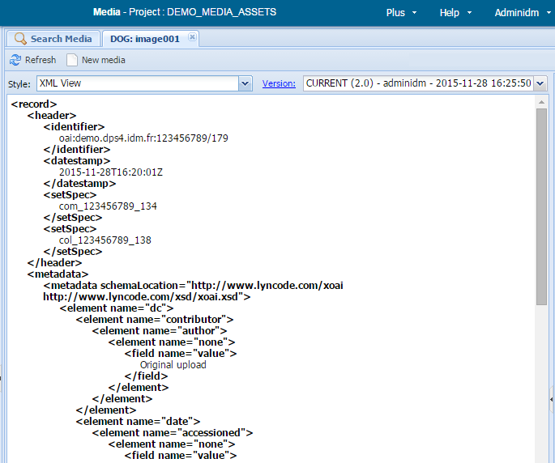

To View Selected XML Tags in the Current Style

Tick the “show tags” tickbox.

Notes:

- Not all tags are shown. Only important divisions of the media record are displayed.

- This option is not available for all projects.
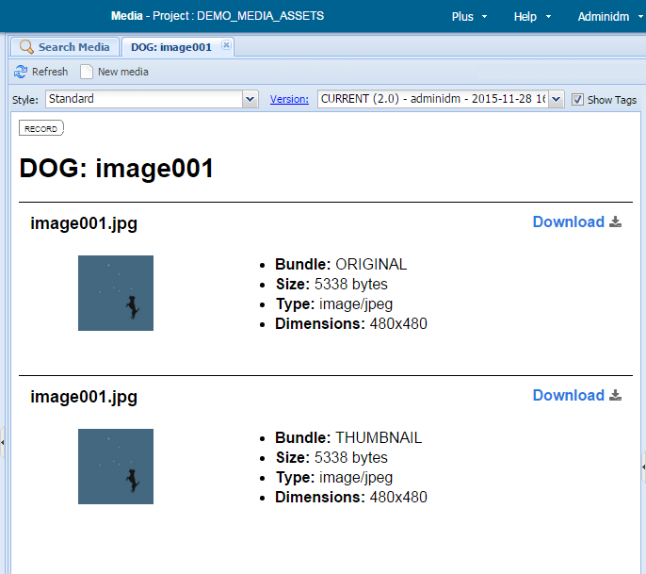

To Download a Media Item

Click the “Download” link next to the variant you wish to download.

Some media types, such as images, will be opened in a new browser tab, from where they can be saved.

Other media types, such as sound files, will be downloaded to your “Downloads” folder.

Working with Media Record Versions

When you first open a media record for viewing, its current version is displayed.

To Display a List of Media Record Versions

- Click the “Version:” button.
This displays the media record’s version table.

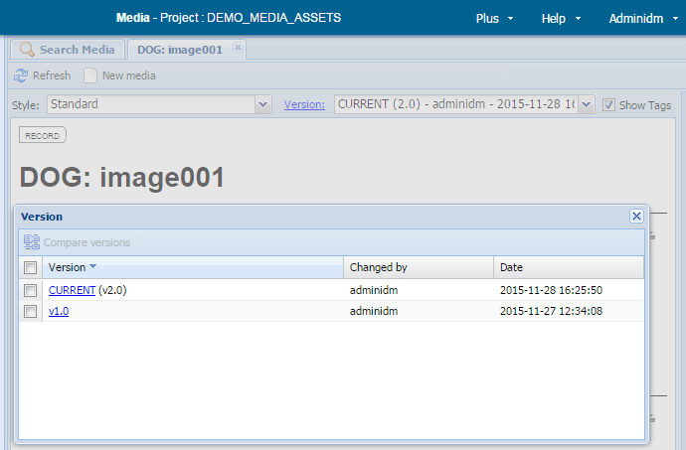

To View an Earlier Version

Either

- Select the desired version for the versions dropdown.

or

- Display the version table.

- Click on the version number you wish to view.

When you view a version that is not the current version:

- The banner displays the warning message:

You are viewing an old version of this document.

- These additional options are available:

  - Compare with current version: compares the version you are viewing with the current version.

  - View current version: reverts to viewing the current version.

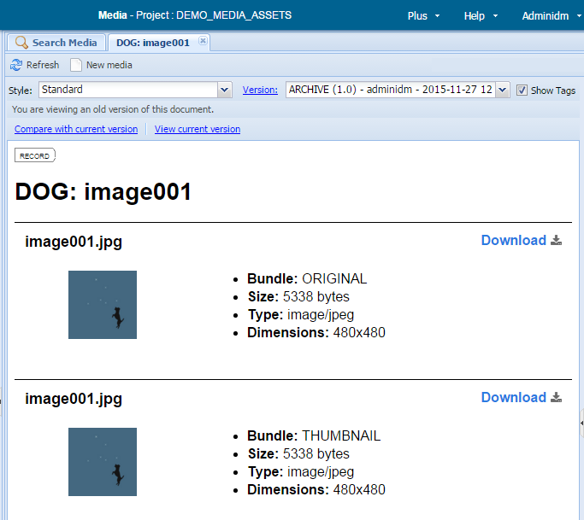

To Compare Two Media Record Versions

- Display the version table.

- Select two versions.

- Click the “Compare versions” button.

If version Y is compared with an earlier version X:

- The differences are shown in a style that displays all XML tagging. No other styles are available.

- Content deleted from version X to create version Y is shown on a red background.

- Content added to version X to create version Y is shown on a green background.

- Content that is unchanged between X and Y is shown on a white background.

- The banner displays the line:

Versions compared: X vs Y

Clicking on X or Y will display that version.

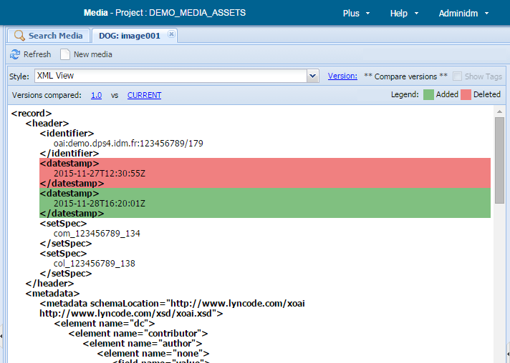

Explanation

Styles

Each DPS media record project provides one or more display styles to display media records in different ways. Usually two styles are provided:

- A preview style that

(a) shows all variants of the media item, and

(b) formats associated metadata in a user-friendly way.

- A raw style that displays the media record’s full XML tagging.

Media Record Versions

DPS maintains a full version history of all media records. Once saved in the central repository, versions are never overwritten: when media records are modified, a new version is created.

The latest version of a media record in the repository is called the current version; all earlier versions are called archive versions. Normally you work with the current version.

Version Table

The version table displays this information for each version of a media record:

- Version: the version number, in the form “vX.0.”

  - Exception: the current version is labeled “CURRENT (vX.0).

- Changed by: the user name of the person who created the version.

- Date: the date and time the version was created.

Creating Media Records

In the Search Media Panel

- Click the “New Media” button.

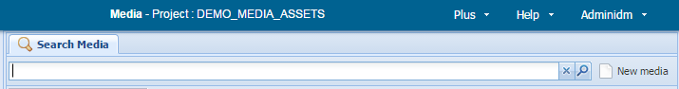

In the Create Media Panel

- Choose the collection to which the new media should be added.

- Specify the file that contains the media item by dragging it to the “Drop file here...” zone.

  - Alternative: click on the “Drop file here...” zone to open a file-selection popup.

- Specify a title for the media item. This will become the media record’s label.

- Click the “OK” button.

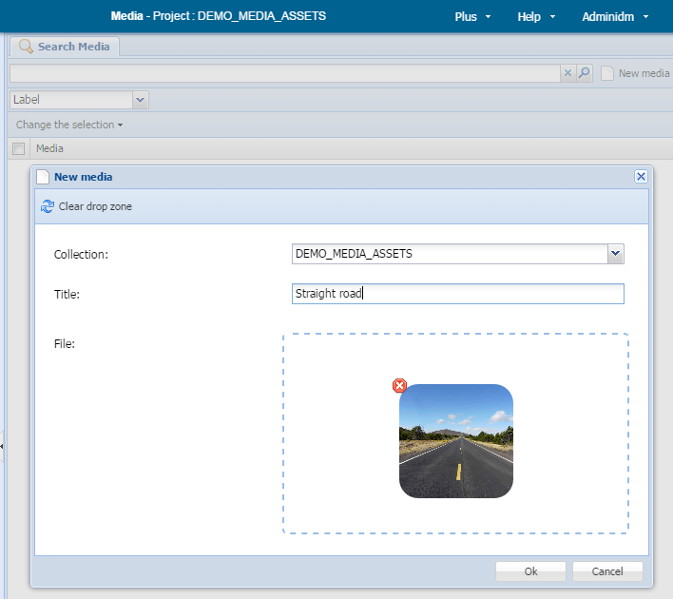

Explanation

Collections

A media items managed by a DPS media project are stored in groups called “collections”. Which media collections are associated with a given DPS media project is determined by the project’s configuration. The default is for one collection to be associated with a DPS media project. If a project has more than one associated media collection, you can choose the one to hold new media items you create.

Inserting Media into Documents

Introduction

Strictly speaking media items are never inserted into documents; rather, links are inserted to media items held in a DPS media project. For all practical purposes this comes to the same thing. These links are a special type of cross-reference, and inserting and updating them uses the same procedures as for cross-references (see Editing documents).

To Insert a Media Item

- Place the cursor where you wish to insert the media item: either place it in textual content or select a whole element. The selected location should be a place where the desired media type is allowed by the DTD.

- Click on the “Create cross-reference” button. This displays the create cross-reference popup.

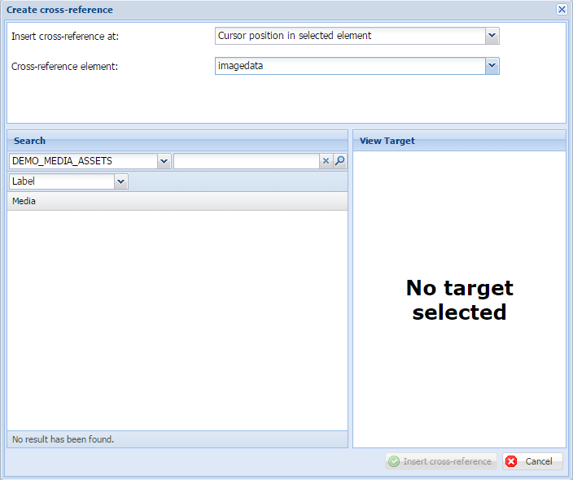

- Select the position to insert the cross-reference:

  - Start in selected element.

  - End in selected element.

  - Cursor position in selected element (not available if a whole element has been selected).

- From the cross-reference element dropdown, choose the element that matches the type of media you wish to insert. For example, “img” might be appropriate for images.

- Search for the target media entry in the “Search” panel:

  - Select the media project that contains the media item. (This will probably be set correctly for you when you choose the element in step 4.)

  - Select the search mode.

  - Specify a search term consistent with the selected search mode.

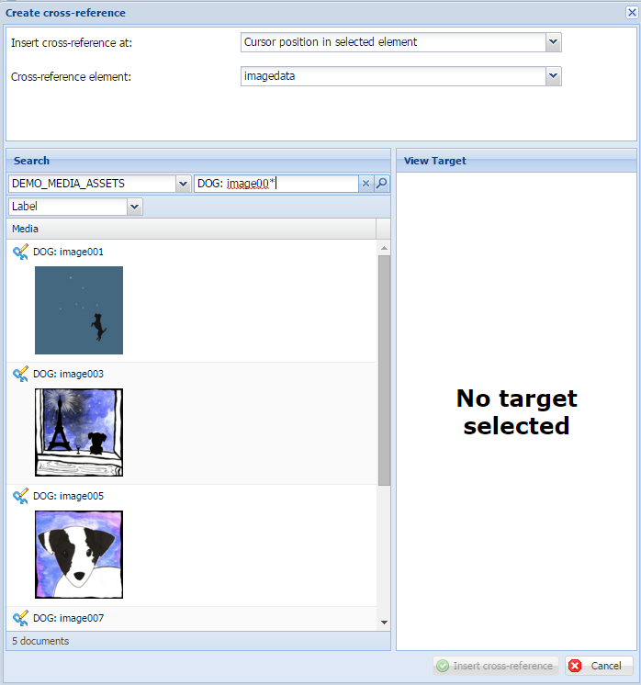

- Select the desired media entry from the result list by clicking on its cross-reference icon:

- The media entry’s content is displayed in the “View target” panel. If it is not the correct media entry, you can pick another from the result list or run a new search.

- Select the desired target element within the media entry. Only valid target elements are shown:

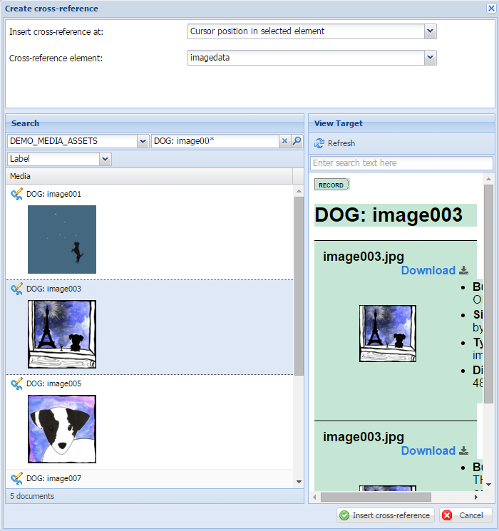

- Click the “Insert cross-reference” button.

To edit an existing media link

- Click on a link to select it.

- Open the cross-reference editor by clicking on the “Edit cross-reference” button. The current target media entry is opened in the “View Target” panel.

- If necessary, search for a new media entry in the “Search” panel.

- Select the desired target element within the media entry.

- Click the “Update cross-reference” button.

To update a media link

- Click on a link to select it.

- Update the link by clicking on “Update cross-reference” button.

Note: this option is not generally useful because DPS automatically keeps the media links up-to-date. Only use it to refresh links where you know the target media item has changed but the link has not been updated.

Appendices

DAT Staff

Full Name | Role | Years Active
Bowers, Kate | Lexicographer | XXX–present
Chute, Tamar | Lexicographer | XXX–present
Huth, Geof | Lexicographer | XXX–present
Hyslop, Andrew | Lexicographer | XXX–present
Pleva-Flynn, Rosemary | General Editor | XXX–present
Ruwell, Mary Elizabeth | Lexicographer | XXX–present
Schmitz, Dawn | Lexicographer | XXX–present
Sly, Margery | Lexicographer | XXX–present
Turrini, Joseph | Lexicographer | XXX–XXX

Lexicographer’s Initials for Subject Tagging

Initials | Full Name
AH | Andrew Hyslop
DS | Dawn Schmitz
GH | Geof Huth
JT | Joseph Turrini
KB | Kate Bowers
MER | Mary Elizabeth Ruwell
MS | Margery Sly
RPF | Rosemary Pleva-Flynn
TC | Tamar Chute

“Help:Pronunciation respelling key,” Wikipedia: The Free Encyclopedia, available at https://en.wikipedia.org/wiki/Help:Pronunciation_respelling_key, accessed 23 May 2016.
“Pronunciation respelling for English,” Wikipedia: The Free Encyclopedia, available at https://en.wikipedia.org/wiki/Pronunciation_respelling_for_English, accessed 24 May 2016.
Pronounced /ɔː/ in accents that distinguish between “cot” and “caught.” Pronounced /ɒ/ in accents that do not distinguish that pair.

